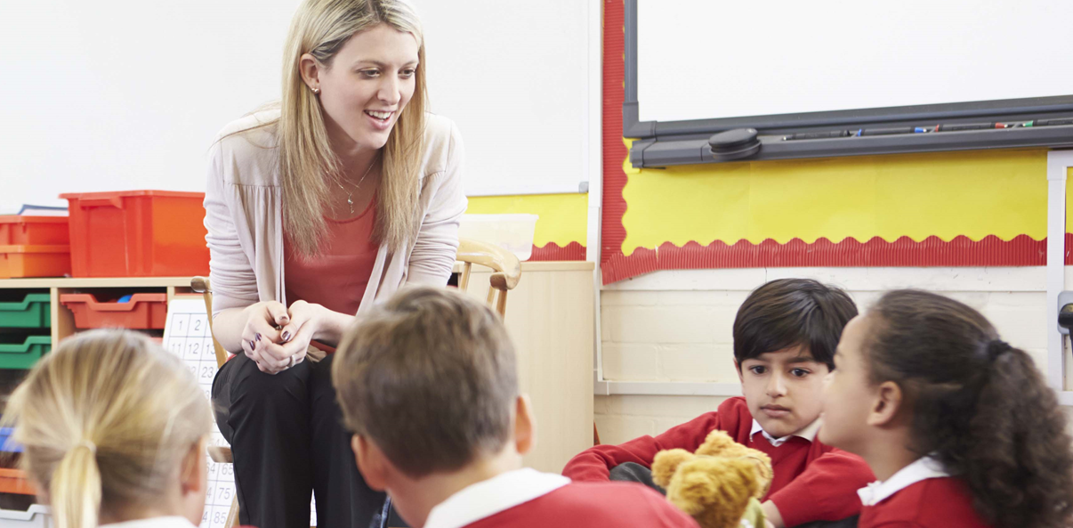
Faldingworth and Normanby by Spital School
Fair Acres Federation
PSHE Progression Document

Intent
At the Fair Acres Federation, we aim deliver a curriculum which is accessible to all and that will maximise the outcomes for every child so that they know more, remember more, and understand more. We believe that the purpose of PSHE education is to build, where appropriate, on the statutory content already outlined in the national curriculum, the basic school curriculum and in statutory guidance on: drug education, financial education, citizenship, personal safety, sex and relationship education (RSE) and the importance of physical activity and diet for a healthy lifestyle. At the Fair Acres Federation, personal, social, health and economic (PSHE) education enables our children to become healthy, independent and responsible members of a society. It aims to help them understand how they are developing personally and socially and tackles many of the moral, social and cultural issues that are part of growing up. We provide our children with opportunities for them to learn about rights and responsibilities and appreciate what it means to be a member of a diverse society. Our children are encouraged to develop their sense of self-worth by playing a positive role in contributing to school life and the wider community.

Implement
At the Fair Acres Federation, we deliver the PSHE curriculum by utilising first hand experiences and sharing good practice and it is the responsibility of every member of staff to do this by being a role model and having high expectations of our children. We have tailored the PSHE Associations’ ‘Programme of Study’ to suit our pupils, school and community; considering our school ethos and aims and our pupils’ needs. Non-Negotiables show clear progression and include learning that will take place in KS3. This enables the staff to have a clear view of progression across the curriculum, knowing where they have come from and where they will go beyond primary education.
We follow the PSHE Associations’ three core themes: Health and Wellbeing; Relationships; and Living in the Wider World. Each year group covers content related to each theme every year, ensuring that a spiral programme is in place: one that revisits themes, gradually extending thinking, expanding knowledge, and developing skills, making constant links to previous learning and experiences, and building upon these. PSHE is a vital part of primary education and needs to be taught at least weekly.
This PSHE learning comes in many different forms: through whole-class teaching, group activities, individual tasks, assemblies, outside speakers, cross-curricular and discrete lessons.
During PSHE sessions children are encouraged to both ask and answer questions, to deepen their knowledge and understanding.

Impact
- Children will demonstrate and apply the British Values of Democracy, Tolerance, Mutual respect, Rule of law and Liberty.
- Children will demonstrate a healthy outlook towards school.
- Children will become healthy and responsible members of society.
- Children will be on their journey preparing them for life and work in modern Britain.

Our approach to the curriculum results in a fun, engaging and high-quality PSHE program. The quality of children’s learning is recorded in a class scrapbook. Children also carry out ‘Proof of Progress’ (POP) Tasks on a regular basis, which is a cold assessment of the children’s learning and understanding. Evidence such as this is used to feed into teachers’ future planning allowing teachers to revisit and discuss misconceptions. This supports varied paces of learning and ensures all pupils make good progress.
Much of the subject-specific knowledge developed in our PSHE lessons equips pupils with experiences which will benefit them in becoming a positive citizen in a forever changing community.
Yearly coverage/ blocking
 | Term 1 | Term 2
Autumn | Relationships  - Families and Friendship  - Safe Relationships | Health and Wellbeing  - Physical health and mental wellbeing  - Keeping safe
Spring | Living in the Wider World  - Belonging to a community  - Money and work | Relationships  - Respecting ourselves and others
Summer | Living in the Wider World  - Media literacy and digital resilience | Health and Wellbeing  - Growing and changing

Progression of Knowledge

Content | Year 1 | Year 2 | Year 3 | Year 4 | Year 5 | Year 6 | Year 7
Relationships  - Families and friendships  - Safe Relationships  All year groups  I know about/I know how  EYFS  Talk about feelings and their and others behavior.  Know that some behavior is unacceptable.  Work as part of a group and class.  Know that we are all different and that it is okay.  Know that some behavior is unacceptable.  Work as part of a group. | Roles of different  people; families;  feeling cared for.  • about people who care for them, e.g. parents, siblings, grandparents, relatives, friends, teachers  • the role these different people play in children’s lives and how they care for them  • what it means to be a family and how families are different, e.g. single parents, same-sex parents, etc.  • about the importance of telling someone — and how to tell them — if they are worried about something in their family  Recognising privacy;  staying safe; seeking  permission  • about situations when someone’s body or feelings might be hurt and whom to go to for help  • about what it means to keep something private, including parts of the body that are private  • to identify different types of touch and how they make people feel (e.g.hugs, tickling, kisses and punches)  • how to respond if being touched makes them feel uncomfortable or unsafe  • when it is important to ask for permission to touch others  • how to ask for and give/not give permission  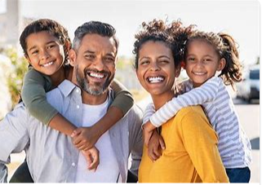 | Making friends;  feeling lonely and  getting help  • how to be a good friend, e.g. kindness, listening, honesty  • about different ways that people meet and make friends  • strategies for positive play with friends, e.g. joining in, including others, etc.  • about what causes arguments between friends  • how to positively resolve arguments between friends  • how to recognise, and ask for help, when they are feeling lonely or unhappy or to help someone else  Managing secrets;  resisting pressure  and getting help;  recognising hurtful  behaviour  • how to recognise hurtful behaviour, including online  • what to do and whom to tell if they see or experience hurtful behaviour, including  online  • about what bullying is and different types of bullying  • how someone may feel if they are being bullied  • about the difference between happy surprises and secrets that make them feel  uncomfortable or worried, and how to get help  • how to resist pressure to do something that feels uncomfortable or unsafe  • how to ask for help if they feel unsafe or worried and what vocabulary to use  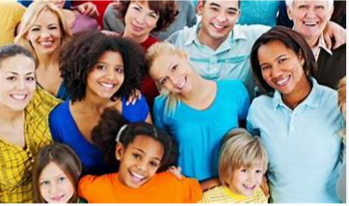 | What makes a family; features of family life  • to recognise and respect that there are different types of families, including single parents, same-sex parents, step-parents, blended families, foster and adoptive parents  • that being part of a family provides support, stability and love  • about the positive aspects of being part of a family, such as spending time together  and caring for each other  • about the different ways that people can care for each other e.g. giving  encouragement or support in times of difficulty  • to identify if/when something in a family might make someone upset or worried  • what to do and whom to tell if family relationships are making them feel unhappy or unsafe  Personal boundaries; safely responding  to others; the impact of hurtful behaviour  • What is appropriate to share with friends, classmates, family and wider social groups  including online  • about what privacy and personal boundaries are, including online  • basic strategies to help keep themselves safe online e.g.passwords, using trusted  sites and adult supervision  • that bullying and hurtful behaviour is unacceptable in any situation  • about the effects and consequences of bullying for the people involved  • about bullying online, and the similarities and differences to face-to-face bullying  • what to do and whom to tell if they see or experience bullying or hurtful behaviour | Positive friendships, including online  • about the features of positive healthy friendships such as mutual respect, trust and  sharing interests  • strategies to build positive friendships  • how to seek support with relationships if they feel lonely or excluded  • how to communicate respectfully with friends when using digital devices  • how knowing someone online differs from knowing someone face to face and that there are risks in communicating with someone they don’t know  • what to do or whom to tell if they are worried about any contact online  Responding to hurtful behaviour;  managing confidentiality; recognising  risks online  • to differentiate between playful teasing, hurtful behaviour and bullying, including online  • how to respond if they witness or experience hurtful behaviour or bullying, including online  • recognise the difference between ‘playful dares’ and dares which put someone  under pressure, at risk, or make them feel uncomfortable  • how to manage pressures associated with dares  • when it is right to keep or break a confidence or share a secret  • how to recognise risks online such as harmful content or contact  • how people may behave differently online including pretending to be someone they're not  • how to report concerns and seek help if worried or uncomfortable about someone’s behaviour, including online  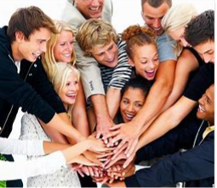 | Managing friendships and peer influence  • what makes a healthy friendship and how they make people feel included  • strategies to help someone feel included  • about peer influence and how it can make people feel or behave  • the impact of the need for peer approval in different situations, including online  • strategies to manage peer influence and the need for peer approval e.g. exit strategies, assertive communication  • that it is common for friendships to experience challenges  • strategies to positively resolve disputes and reconcile differences in friendships  • that friendships can change over time and the benefits of having new and different types of friends  • how to recognise if a friendship is making them feel unsafe, worried, or  uncomfortable  • when and how to seek support in relation to friendships  Physical contact and feeling safe  • to identify what physical touch is acceptable, unacceptable, wanted or unwanted in different situations  • how to ask for, give and not give permission for physical contact  • how it feels in a person’s mind and body when they are uncomfortable  • that it is never someone’s fault if they have experienced unacceptable contact  • how to respond to unwanted or unacceptable physical contact  • that no one should ask them to keep a secret that makes them feel uncomfortable or try to persuade them to keep a secret they are worried about  • whom to tell if they are concerned about unwanted physical contact | Attraction to others; romantic  relationships; civil partnership and  marriage  • what it means to be attracted to someone and different kinds of loving relationships  • that people who love each other can be of any gender, ethnicity or faith  • the difference between gender identity and sexual orientation and everyone’s right to be loved  • about the qualities of healthy relationships that help individuals flourish  • ways in which couples show their love and commitment to one another, including  those who are not married or who live apart  • what marriage and civil partnership mean e.g. a legal declaration of commitment  made by two adults  • that people have the right to choose whom they marry or whether to get married  • that to force anyone into marriage is illegal  • how and where to report forced marriage or ask for help if they are worried  Recognising and managing pressure;  consent in different situations  • to compare the features of a healthy and unhealthy friendship  • about the shared responsibility if someone is put under pressure to do something  dangerous and something goes wrong  • strategies to respond to pressure from friends including online  • how to assess the risk of different online ‘challenges’ and ‘dares’  • how to recognise and respond to pressure from others to do something unsafe or that makes them feel worried or uncomfortable  • how to get advice and report concerns about personal safety, including online  • what consent means and how to seek and give/not give permission in different  situations | Building relationships  Self-worth, romance and friendships (including online) and relationship  boundaries  • how to develop self-worth and self-efficacy  • about qualities and behaviours relating to different types of  positive relationships  • how to recognise unhealthy relationships  • how to recognise and challenge media stereotypes  • how to evaluate expectations for romantic relationships  • about consent, and how to seek and assertively communicate  consent
Vocabulary | Kind, fair, respect, secrets, surprises, sad, happy, unhappy, angry, excited  Healthy, unhealthy, special, relationship, differences | Difference, surprise, relationship, conflict, kind, fair, respect, secret, difference, opinion, boundaries, healthy, unhealthy, happy, sad, frustrated, annoyed, angry, upset, disappointed, excited | Bully, cyber, physical, unkind, mental health, feelings, emotions, unhappy, differences, power, bystander, empathy, acceptance, courage  Friend, kindness, emotions, feelings, care, conflict, qualities | Diversity, prejudice, perceived, stereotype, empathy, conscience, label, self-control, choices, bully, conflicts, challenge, ostracized, mental health, uncomfortable, secret, anxious, fearful, sad, trustworthy, police officer, parent, teacher, physical, | Peer pressure, spoken, unspoken, rejection, put down, reasoning, pressure, peer mediator, respect, bodies, personal hygiene, baby, toddler, child, teenager, adult, elderly, life cycle, puberty, cleanliness | Diverse, stereotype, relationships, religions, gay, lesbian, transgender, step families, blended families, reflect, respect  Relationships, inappropriate, puberty, male, female, parent, respect, sex, menstruation sanitary products, contraception, life cycle, +any specific anatomy knowledge

Content | Year 1 | Year 2 | Year 3 | Year 4 | Year 5 | Year 6 | Year 7
Relationships  - Respecting ourselves and others  All year groups  I know about/I know how  EYFS  Talk about feelings and their and others behavior.  Know that some behavior is unacceptable.  Work as part of a group and class.  Know that we are all different and that it is okay.  Know that some behaviour is unacceptable  Work as part of a group. | How behaviour  affects others; being  polite and respectful  • what kind and unkind behaviour mean in and out school  • how kind and unkind behaviour can make people feel  • about what respect means  • about class rules, being polite to others, sharing and taking turns  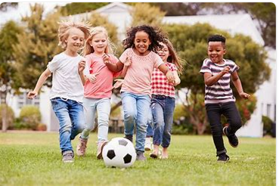 | Recognising things  in common and  differences; playing  and working cooperatively.  sharing opinions  • about the things they have in common with their friends, classmates, and other  people  • how friends can have both similarities and differences  • how to play and work cooperatively in different groups and situations  • how to share their ideas and listen to others, take part in discussions, and give  reasons for their views | Recognising respectful behaviour; the importance of self-respect; courtesy and being polite  • to recognise respectful behaviours e.g. helping or including others, being  responsible  • how to model respectful behaviour in different situations e.g. at home, at school,  online  • the importance of self-respect and their right to be treated respectfully by others  • what it means to treat others, and be treated, politely  • the ways in which people show respect and courtesy in different cultures and in  wider society | Respecting differences and similarities.  discussing difference sensitively  • to recognise differences between people such as gender, race, faith  • to recognise what they have in common with others e.g. shared values, likes and  dislikes, aspirations  • about the importance of respecting the differences and similarities between people  • a vocabulary to sensitively discuss difference and include everyone  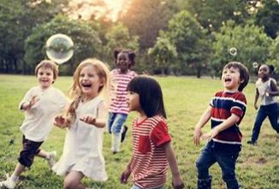 | Responding respectfully to a wide range of people; recognising prejudice and  discrimination  • to recognise that everyone should be treated equally  • why it is important to listen and respond respectfully to a wide range of people,  including those whose traditions, beliefs and lifestyle are different to their own  • what discrimination means and different types of discrimination e.g. racism, sexism,  homophobia  • to identify online bullying and discrimination of groups or individuals e.g. trolling and  harassment  • the impact of discrimination on individuals, groups and wider society  • ways to safely challenge discrimination  • how to report discrimination online | Expressing opinions and respecting  other points of view, including discussing  topical issues  • about the link between values and behaviour and how to be a positive role model  • how to discuss issues respectfully  • how to listen to and respect other points of view  • how to constructively challenge points of view they disagree with  • ways to participate effectively in discussions online and manage conflict or  disagreements | Diversity  Diversity, prejudice, and bullying  • about identity, rights, and responsibilities  • about living in a diverse society  • how to challenge prejudice, stereotypes, and discrimination  • the signs and effects of all types of bullying, including online  • how to respond to bullying of any kind, including online  • how to support others  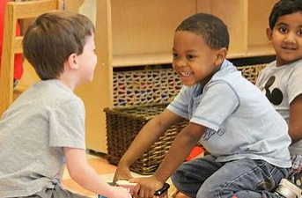
Vacabulary | Kind, fair, respect, secrets, surprises, sad, happy, unhappy, angry, excited  Healthy, unhealthy, special, relationship, differences | Difference, surprise, relationship, conflict, kind, fair, respect, secret, difference, opinion, boundaries, healthy, unhealthy, happy, sad, frustrated, annoyed, angry, upset, disappointed, excited | Bully, cyber, physical, unkind, mental health, feelings, emotions, unhappy, differences, power, bystander, empathy, acceptance, courage  Friend, kindness, emotions, feelings, care, conflict, qualities | Diversity, prejudice, perceived, stereotype, empathy, conscience, label, self-control, choices, bully, conflicts, challenge, ostracized, mental health, uncomfortable, secret, anxious, fearful, sad, trustworthy, police officer, parent, teacher, physical, acceptable, necessary, | Peer pressure, spoken, unspoken, rejection, put down, reasoning, pressure, peer mediator, respect, bodies, personal hygiene, baby, toddler, child, teenager, adult, elderly, life cycle, puberty, cleanliness | Diverse, stereotype, relationships, religions, gay, lesbian, transgender, step families, blended families, reflect, respect  Relationships, inappropriate, puberty, male, female, parent, respect, sex, menstruation sanitary products, contraception, life cycle, +any specific anatomy knowledge

Content | Year 1 | Year 2 | Year 3 | Year 4 | Year 5 | Year 6 | Year 7
Living in the wider world  - Belonging to a community  - Money and work  All year groups  I know about/I know how  EYFS  Understand and follow the rules.  Adjust behavior to different situations and take changes of routine in their stride.  Know why we have rules.  Be able to follow rules.  Start to say why and how things are right and wrong.  Begin to understand the importance of money.  Listen to others when they speak. | What rules are; caring for others’ needs; looking after the environment  • about examples of rules in different situations, e.g. class rules, rules at home, rules  outside  • that different people have different needs  • how we care for people, animals and other living things in different ways  • how they can look after the environment, e.g. recycling  Strengths and interests; jobs in the  community  • that everyone has different strengths, in and out of school  • about how different strengths and interests are needed to do different jobs  • about people whose job it is to help us in the community  • about different jobs and the work people do  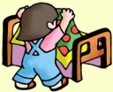 | Belonging to a group; roles and  responsibilities; being the same and  different in the community  • about being a part of different groups, and the role they play in these groups e.g.  class, teams, faith groups  • about different rights and responsibilities that they have in school and the wider  community  • about how a community can help people from different groups to feel included  • to recognise that they are all equal, and ways in which they are the same and different to others in their community  What money is; needs and wants.  looking after money  • about what money is and its different forms e.g. coins, notes, and ways of paying for  things e.g. debit cards, electronic payments  • how money can be kept and looked after  • about getting, keeping and spending money  • that people are paid money for the job they do  • how to recognise the difference between needs and wants  • how people make choices about spending money, including thinking about needs  and wants  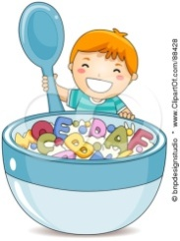 | The value of rules and laws; rights,  freedoms and responsibilities  • the reasons for rules and laws in wider society  • the importance of abiding by the law and what might happen if rules and laws are  broken  • what human rights are and how they protect people  • to identify basic examples of human rights including the rights of children  • about how they have rights and also responsibilities  • that with every right there is also a responsibility e.g. the right to an education and  the responsibility to learn  Different jobs and skills; job stereotypes.  setting personal goals  • about jobs that people may have from different sectors e.g. teachers, business  people, charity work  • that people can have more than one job at once or over their lifetime  • about common myths and gender stereotypes related to work  • to challenge stereotypes through examples of role models in different fields of work  e.g. women in STEM  • about some of the skills needed to do a job, such as teamwork and decision-making  • to recognise their interests, skills and achievements and how these might link to  future jobs  • how to set goals that they would like to achieve this year e.g. learn a new hobby | What makes a community; shared  responsibilities  • the meaning and benefits of living in a community  • to recognise that they belong to different communities as well as the school  community  • about the different groups that make up and contribute to a community  • about the individuals and groups that help the local community, including through  volunteering and work  • how to show compassion towards others in need and the shared responsibilities of  caring for them  Making decisions about money; using and keeping money safe  • how people make different spending decisions based on their budget, values and  needs  • how to keep track of money and why it is important to know how much is being  spent  • about different ways to pay for things such as cash, cards, e-payment and the  reasons for using them  • that how people spend money can have positive or negative effects on others e.g.  charities, single use plastics | Protecting the environment; compassion  towards others  • about how resources are allocated and the effect this has on individuals,  communities and the environment  • the importance of protecting the environment and how everyday actions can either support or damage it  • how to show compassion for the environment, animals and other living things  • about the way that money is spent and how it affects the environment  • to express their own opinions about their responsibility towards the environment  Identifying job interests and aspirations.  what influences career choices.  workplace stereotypes  • to identify jobs that they might like to do in the future  • about the role ambition can play in achieving a future career  • how or why someone might choose a certain career  • about what might influence people’s decisions about a job or career, including pay,  working conditions, personal interests, strengths and qualities, family, values  • the importance of diversity and inclusion to promote people’s career opportunities  • about stereotyping in the workplace, its impact and how to challenge it  • that there is a variety of routes into work e.g. college, apprenticeships, university,Training  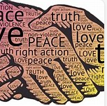 | Valuing diversity; challenging  discrimination and stereotypes  • what prejudice means  • to differentiate between prejudice and discrimination  • how to recognise acts of discrimination  • strategies to safely respond to and challenge discrimination  • how to recognise stereotypes in different contexts and the influence they have on  attitudes and understanding of different groups  • how stereotypes are perpetuated and how to challenge this  Influences and attitudes to money.  money and financial risks  • about the role that money plays in people’s lives, attitudes towards it and what  influences decisions about money  • about value for money and how to judge if something is value for money  • how companies encourage customers to buy things and why it is important to be a  critical consumer  • how having or not having money can impact on a person’s emotions, health and  wellbeing  • about common risks associated with money, including debt, fraud and gambling  • how money can be gained or lost e.g. stolen, through scams or gambling and how  these put people at financial risk  • how to get help if they are concerned about gambling or other financial risks | Developing skills and  aspirations  Careers, teamwork and enterprise skills, and raising aspirations  • how to be enterprising, including skills of problem-solving,  communication, teamwork, leadership, risk-management, and  creativity  • about a broad range of careers and the abilities and qualities  required for different careers  • about equality of opportunity  • how to challenge stereotypes, broaden their horizons and how  to identify future career aspirations  • about the link between values and career choices  Financial decision making  Saving, borrowing,  budgeting and making financial choices  • how to make safe financial choices  • about ethical and unethical business practices and consumerism  • about saving, spending and budgeting  • how to manage risk-taking behaviour  
Vocabulary | Rules, needs, communities, groups, harm, environment, money, save, spend, choice | Rules, needs, communities, groups, harm, environment, money, save, spend, choice, influence, manage, source, awareness, needs | Fair, rules, rights, responsibilities, respect, conflict, disagreement, help, safe, risk, resolve, different, similar, diverse, respect, views, experiences, expectations, charity, fundraiser, community, pressure groups, volunteer, voluntary, democracy, vote | Rules, laws, rights, responsibilities, community, anti-social, road safety, British values, customs, birthplace, extended families, citizen, etiquette, diverse, stereotype, racism, power, superiority, discrimination | Community, council, councillors, laws, anti-social, responsibility, organizations, research, Right, responsibility, entitlement, shelter, education, healthcare, society | Community, council, councillors, laws, anti-social, responsibility, organizations, research, Right, responsibility, entitlement, shelter, education, healthcare, society

Content | Year 1 | Year 2 | Year 3 | Year 4 | Year 5 | Year 6 | Year 8
Living in the wider world  - Media literacy and digital resilience  All year groups  I know about/I know how  EYFS  Understand and follow the rules.  Adjust behaviour to different situations and take changes of routine in their stride.  Know why we have rules.  Be able to follow rules.  Start to say why and how things are right and wrong.  Begin to understand the importance of money.  Listen to others when they speak. | Using the internet and digital devices.  communicating online  • how and why people use the internet  • the benefits of using the internet and digital devices  • how people find things out and communicate safely with others online  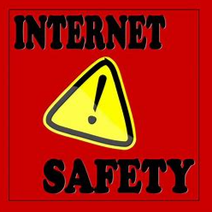 | The internet in everyday life; online  content and information  • the ways in which people can access the internet e.g. phones, tablets, computers  • to recognise the purpose and value of the internet in everyday life  • to recognise that some content on the internet is factual and some is for  entertainment e.g. news, games, videos  • that information online might not always be true  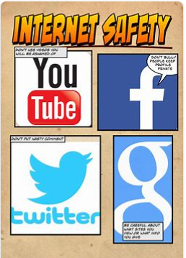 | How the internet is used.  assessing  information online  • how the internet can be used positively for leisure, for school and for work  • to recognise that images and information online can be altered or adapted and the  reasons for why this happens  • strategies to recognise whether something they see online is true or accurate  • to evaluate whether a game is suitable to play, or a website is appropriate for their age-group  • to make safe, reliable choices from search results  • how to report something seen or experienced online that concerns them e.g. images  or content that worry them, unkind or inappropriate communication | How data is shared and used  • that everything shared online has a digital footprint  • that organisations can use personal information to encourage people to buy things  • to recognise what online adverts look like  • to compare content shared for factual purposes and for advertising  • why people might choose to buy or not buy something online e.g. from seeing an  advert  • that search results are ordered based on the popularity of the website and that this  can affect what information people access  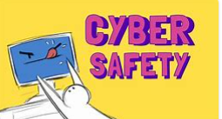 | How information online is targeted.  different media types, their role and impact  • to identify different types of media and their different purposes e.g. to entertain,  inform, persuade or advertise  • basic strategies to assess whether content online (e.g. research, news, reviews,  blogs) is based on fact, opinion, or is biased  • that some media and online content promote stereotypes  • how to assess which search results are more reliable than others  • to recognise unsafe or suspicious content online  • how devices store and share information | Evaluating media sources; sharing things online  • about the benefits of safe internet use e.g. learning, connecting and communicating  • how and why images online might be manipulated, altered, or faked  • how to recognise when images might have been altered  • why people choose to communicate through social media and some of the risks and  challenges of doing so  • that social media sites have age restrictions and regulations for use  • the reasons why some media and online content is not appropriate for children  • how online content can be designed to manipulate people’s emotions and  encourage them to read or share things  • about sharing things online, including rules and laws relating to this  • how to recognise what is appropriate to share online  • how to report inappropriate online content or contact | Digital literacy  Online safety, digital  literacy, media reliability,  and gambling hooks  • about online communication  • how to use social networking sites safely  • how to recognise online grooming in different forms, e.g. in  relation to sexual or financial exploitation, extremism and  radicalisation  • how to respond and seek support in cases of online grooming  • how to recognise biased or misleading information online  • how to critically assess different media sources  • how to distinguish between content which is publicly and  privately shared  • about age restrictions when accessing different forms of media  and how to make responsible decisions  • how to protect financial security online  • how to assess and manage risks in relation to gambling and chance-based transactions
Vocabulary | Rules, needs, communities, groups, harm, environment, money, save, spend, choice | Rules, needs, communities, groups, harm, environment, money, save, spend, choice, influence, manage, source, awareness, needs | Fair, rules, rights, responsibilities, respect, conflict, disagreement, help, safe, risk, resolve, different, similar, diverse, respect, views, experiences, expectations, charity, fundraiser, community, pressure groups, volunteer, voluntary, democracy, vote | Rules, laws, rights, responsibilities, community, anti-social, road safety, British values, customs, birthplace, extended families, citizen, etiquette, diverse, stereotype, racism, power, superiority, discrimination | Community, council, councillors, laws, anti-social, responsibility, organizations, research, Right, responsibility, entitlement, shelter, education, healthcare, society | Community, council, councillors, laws, anti-social, responsibility, organizations, research, Right, responsibility, entitlement, shelter, education, healthcare, society

Content | Year 1 | Year 2 | Year 3 | Year 4 | Year 5 | Year 6 | Year 7
Health and wellbeing  - Physical health and mental wellbeing  - Keeping safe  All year groups  I know about/I know how  EYFS  Know the importance for good health of physical exercise and a healthy diet.  Manage basic hygiene.  Know that we should eat a healthy diet  Be able to say what foods are healthy  Know why we exercise  Manage their own personal hygiene.  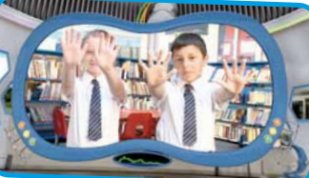 | Keeping healthy; food and exercise.  hygiene routines; sun safety  • what it means to be healthy and why it is important  • ways to take care of themselves on a daily basis  • about basic hygiene routines, e.g. hand washing  • about healthy and unhealthy foods, including sugar intake  • about physical activity and how it keeps people healthy  • about different types of play, including balancing indoor, outdoor and screen-based  play  • about people who can help them to stay healthy, such as parents, doctors, nurses,  dentists, lunch supervisors  • how to keep safe in the sun  How rules and age restrictions help us  keeping safe online  • how rules can help to keep us safe  • why some things have age restrictions, e.g. TV and film, games, toys or play areas  • basic rules for keeping safe online  • whom to tell if they see something online that makes them feel unhappy, worried, or  Scared   | Why sleep is important; medicines and keeping healthy; keeping teeth healthy; managing feelings and asking for help  • about routines and habits for maintaining good physical and mental health  • why sleep and rest are important for growing and keeping healthy  • that medicines, including vaccinations and immunisations, can help people stay  healthy and manage allergies  • the importance of, and routines for, brushing teeth and visiting the dentist  • about food and drink that affect dental health  • how to describe and share a range of feelings  • ways to feel good, calm down or change their mood e.g. playing outside, listening to  music, spending time with others  • how to manage big feelings including those associated with change, loss and  bereavement  • when and how to ask for help, and how to help others, with their feelings  Safety in different environments; risk  and safety at home; emergencies  • how to recognise risk in everyday situations, e.g. road, water and rail safety,  medicines  • how to help keep themselves safe in familiar and unfamiliar environments, such as  in school, online and ‘out and about’  • to identify potential unsafe situations, who is responsible for keeping them safe  in these situations, and steps they can take to avoid or remove themselves from  danger  • how to help keep themselves safe at home in relation to electrical appliances, fire  safety and medicines/household products  • about things that people can put into their body or onto their skin (e.g. medicines  and creams) and how these can affect how people feel  • how to respond if there is an accident and someone is hurt  • about whose job it is to keep us safe and how to get help in an emergency,  including how to dial 999 and what to say | Health choices and habits; what affects  feelings; expressing feelings  • about the choices that people make in daily life that could affect their health  • to identify healthy and unhealthy choices (e.g. in relation to food, exercise, sleep)  • what can help people to make healthy choices and what might negatively influence  them  • about habits and that sometimes they can be maintained, changed or stopped  • the positive and negative effects of habits, such as regular exercise or eating too  much sugar, on a healthy lifestyle  • what is meant by a healthy, balanced diet including what foods should be eaten  regularly or just occasionally  • that regular exercise such as walking, or cycling has positive benefits for their mental  and physical health  • about the things that affect feelings both positively and negatively  • strategies to identify and talk about their feelings  • about some of the different ways people express feelings e.g. words, actions, body  language  • to recognise how feelings can change overtime and to become more or less powerful  Risks and hazards; safety in the local  environment and unfamiliar places  • how to identify typical hazards at home and in school  • how to predict, assess and manage risk in everyday situations e.g. crossing the road,  running in the playground, in the kitchen  • about fire safety at home including the need for smoke alarms  • the importance of following safety rules from parents and other adults  • how to help keep themselves safe in the local environment or unfamiliar places,  including road, rail, water and firework safety | Maintaining a balanced lifestyle; oral hygiene and dental care  • to identify a wide range of factors that maintain a balanced, healthy lifestyle,  physically and mentally  • what good physical health means and how to recognise early signs of physical illness  • that common illnesses can be quickly and easily treated with the right care e.g. visiting the doctor when necessary  • how to maintain oral hygiene and dental health, including how to brush and floss correctly  • the importance of regular visits to the dentist and the effects of different foods, drinks and substances on dental health  Medicines and household products  drugs common to everyday life  • the importance of taking medicines correctly and using household products safely  • to recognise what is meant by a ‘drug’  • that drugs common to everyday life (e.g. cigarettes, e-cigarettes/vaping, alcohol and  medicines) can affect health and wellbeing  • to identify some of the effects related to different drugs and that all drugs, including  medicines, may have side effects  • to identify some of the risks associated with drugs common to everyday life  • that for some people using drugs can become a habit which is difficult to break  • how to ask for help or advice  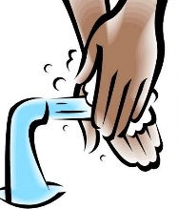 | Healthy sleep habits; sun safety.  medicines, vaccinations, immunisations  and allergies  • how sleep contributes to a healthy lifestyle  • healthy sleep strategies and how to maintain them  • about the benefits of being outdoors and in the sun for physical and mental health  • how to manage risk in relation to sun exposure, including skin damage and heat stroke  • how medicines can contribute to health and how allergies can be managed  • that some diseases can be prevented by vaccinations and immunisations  • that bacteria and viruses can affect health  • how they can prevent the spread of bacteria and viruses with everyday hygiene routines  • to recognise the shared responsibility of keeping a clean environment  Keeping safe in different situations,  including responding in emergencies,  first aid and FGM  • to identify when situations are becoming risky, unsafe or an emergency  • to identify occasions where they can help take responsibility for their own safety  • to differentiate between positive risk taking (e.g. trying a challenging new sport) and  dangerous behaviour  • how to deal with common injuries using basic first aid techniques  • how to respond in an emergency, including when and how to contact different  emergency services  • that female genital mutilation (FGM) is against British law¹  • what to do and whom to tell if they think they or someone they know might be at  risk of FGM | What affects mental health and ways to  take care of it; managing change, loss and bereavement; managing time online  • that mental health is just as important as physical health and that both needs looking after  • to recognise that anyone can be affected by mental ill-health and that difficulties  can be resolved with help and support  • how negative experiences such as being bullied or feeling lonely can affect mental  wellbeing  • positive strategies for managing feelings  • that there are situations when someone may experience mixed or conflicting feelings  • how feelings can often be helpful, whilst recognising that they sometimes need to  be overcome  • to recognise that if someone experiences feelings that are not so good (most of or all of the time) – help and support is available  • identify where they and others can ask for help and support with mental wellbeing  in and outside school  • the importance of asking for support from a trusted adult  • about the changes that may occur in life including death, and how these can cause conflicting feelings  • that changes can mean people experience feelings of loss or grief  • about the process of grieving and how grief can be expressed  • about strategies that can help someone cope with the feelings associated with change or loss  • to identify how to ask for help and support with loss, grief or other aspects of change  • how balancing time online with other activities helps to maintain their health and wellbeing  • strategies to manage time spent online and foster positive habits e.g. switching phone off at night  • what to do and whom to tell if they are frightened or worried about something they have seen online  Keeping personal information safe  regulations and choices; drug use and the law; drug use and the media  • how to protect personal information online  • to identify potential risks of personal information being misused  • strategies for dealing with requests for personal information or images of themselves  • to identify types of images that are appropriate to share with others and those  which might not be appropriate  • that images or text can be quickly shared with others, even when only sent to one person, and what the impact of this might be  • what to do if they take, share or come across an image which may upset, hurt or embarrass them or others  • how to report the misuse of personal information or sharing of upsetting content/images online  • about the different age rating systems for social media, T.V, films, games and online gaming  • why age restrictions are important and how they help people make safe decisions about what to watch, use or play  • about the risks and effects of different drugs  • about the laws relating to drugs common to everyday life and illegal drugs  • to recognise why people choose to use or not use drugs, including nicotine, alcohol and medicines as well as illegal drugs  • about the organisations where people can get help and support concerning drug use  • how to ask for help if they have concerns about drug use  • about mixed messages in the media relating to drug use and how they might influence opinions and decisions | Health and puberty  Healthy routines, influences on health,  puberty, unwanted contact, and FGM  • how to make healthy lifestyle choices including diet, dental  health, physical activity and sleep  • how to manage influences relating to caffeine, smoking and  alcohol  • how to manage physical and emotional changes during puberty  • about personal hygiene  • how to recognise and respond to inappropriate and unwanted  contact  • about FGM and how to access help and support  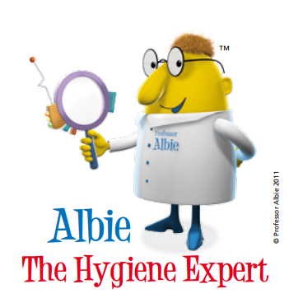
Vocabulary | Exercise, fruit, vegetables, likes, dislike, hygiene, Washing ,Brushing teeth, Get dressed, Clean, Boy, Girl, Penis, Vulva, Same, Different, Physical characteristics , Gender, Hair, Face, choice, mental health, family, trust, safe | Similar , Different, Sex, Gender roles, Stereotypes, Boy, Girl, Male, Female, Body parts, Penis, vulva, Exercise, fruit, vegetables, likes, dislike, hygiene, same, different, gender, trust, safe, family, responsibility, personal identity, mental health | Qualities, role model, teased, feelings, diverse, judge, beautiful, admire, influence, positive, diet, balanced diet, healthy, unhealthy, choice, mental health, aspirations, goals | Drugs, legal, illegal, prescribed, harmful, substances, heart, lungs, brain, stomach, peer pressure  Media, advertising, teased, subjective, beauty, role model, Photoshop, airbrush, respect, appreciate, empower, diet, balanced diet, healthy, unhealthy, choice, mental health | diet, balanced diet, healthy, unhealthy, choice, Substance, medicine, legal, illegal, drugs, effects, risks, prescribes, alcohol, tobacco, role models, risk, predict, potential, hazard, high/medium/low risk, assessing, responsibility | diet, balanced diet, healthy, unhealthy, choice, mental health, Emotions, feelings, positive, negative, achievements, balance, diet, physical, mental, support

Content | Year 1 | Year 2 | Year 3 | Year 4 | Year 5 | Year 6 | Year 7
Health and wellbeing  - Growing and changing  All year groups  I know about/I know how  EYFS  Know the importance for good health of physical exercise and a healthy diet.  Manage basic hygiene.  Know that we should eat a healthy diet  Be able to say what foods are healthy  Know why we exercise  Manage their own personal hygiene. | Recognising what makes them unique  and special; feelings; managing when  things go wrong  • to recognise what makes them special and unique including their likes, dislikes and  what they are good at  • how to manage and whom to tell when finding things difficult, or when things go  wrong  • how they are the same and different to others  • about different kinds of feelings  • how to recognise feelings in themselves and others  • how feelings can affect how people behave  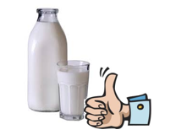 | Growing older; naming body parts  moving class or year  • about the human life cycle and how people grow from young to old  • how our needs and bodies change as we grow up  • to identify and name the main parts of the body including external genitalia (e.g. vulva, vagina, penis, testicles)  • about change as people grow up, including new opportunities and responsibilities  • preparing to move to a new class and setting goals for next year  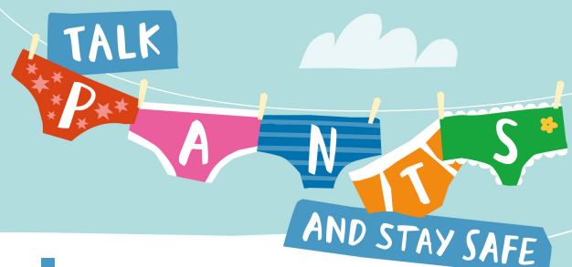 | Personal strengths and achievements  managing and reframing setbacks  • that everyone is an individual and has unique and valuable contributions to make  • to recognise how strengths and interests form part of a person’s identity  • how to identify their own personal strengths and interests and what they’re proud  of (in school, out of school)  • to recognise common challenges to self -worth e.g. finding schoolwork difficult,  friendship issues  • basic strategies to manage and reframe setbacks e.g. asking for help, focusing on  what they can learn from a setback, remembering what they are good at, trying  again | Physical and emotional changes in  puberty; external genitalia; personal  hygiene routines; support with puberty  • how to identify external genitalia and reproductive organs  • about the physical and emotional changes during puberty  • key facts about the menstrual cycle and menstrual wellbeing, erections and wet  dreams  • strategies to manage the changes during puberty including menstruation  • the importance of personal hygiene routines during puberty including washing  regularly and using deodorant  • how to discuss the challenges of puberty with a trusted adult  • how to get information, help and advice about puberty | Personal identity; recognising  individuality and different qualities  mental wellbeing  • about personal identity and what contributes to it, including race, sex, gender,  family, faith, culture, hobbies, likes/dislikes  • that for some people their gender identity does not correspond with their biological  sex  • how to recognise, respect and express their individuality and personal qualities  • ways to boost their mood and improve emotional wellbeing  • about the link between participating in interests, hobbies and community groups  and mental wellbeing  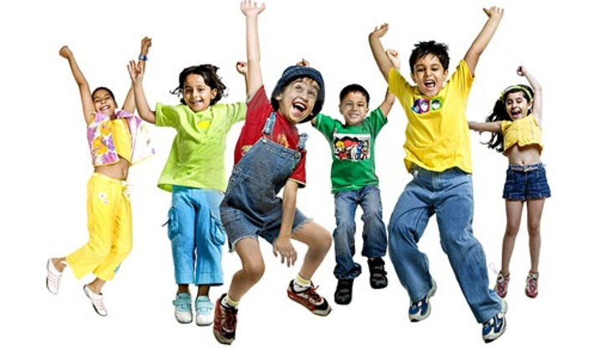 | Human reproduction and birth  increasing independence; managing  transitions  • to recognise some of the changes as they grow up e.g. increasing independence  • about what being more independent might be like, including how it may feel  • about the transition to secondary school and how this may affect their feelings  • about how relationships may change as they grow up or move to secondary school  • practical strategies that can help to manage times of change and transition e.g.  practising the bus route to secondary school  • identify the links between love, committed relationships and conception  • what sexual intercourse is, and how it can be one part of an intimate relationship  between consenting adults  • how pregnancy occurs i.e. when a sperm meets an egg and the fertilised egg settles  into the lining of the womb  • that pregnancy can be prevented with contraception²  • about the responsibilities of being a parent or carer and how having a baby changes someone’s life | Transition and safety  Transition to secondary  school and personal safety  in and outside school,  including first aid  • how to identify, express and manage their emotions in a  constructive way  • how to manage the challenges of moving to a new school  • how to establish and manage friendships  • how to improve study skills  • how to identify personal strengths and areas for development  • personal safety strategies and travel safety, e.g. road, rail and  water  • how to respond in an emergency situation  • basic first aid  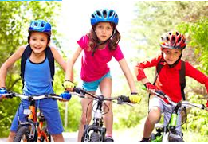
Vocabulary | Exercise, fruit, vegetables, likes, dislike, hygiene, Washing,Brushing teeth, Get dressed, Clean, Boy, Girl, Penis, Vulva, Same, Different, Physical characteristics , Gender, Hair, Face, choice, mental health, family, trust, safe | Similar, Different, Sex, Gender roles, Stereotypes, Boy, Girl, Male, Female, Body parts, Penis, vulva, Exercise, fruit, vegetables, likes, dislike, hygiene, same, different, gender, trust, safe, family, responsibility, personal identity, mental health | Qualities, role model, teased, feelings, diverse, judge, beautiful, admire, influence, positive, diet, balanced diet, healthy, unhealthy, choice, mental health, aspirations, goals | Drugs, legal, illegal, prescribed, harmful, substances, heart, lungs, brain, stomach, peer pressure  Media, advertising, teased, subjective, beauty, role model, Photoshop, airbrush, respect, appreciate, empower, diet, balanced diet, healthy, unhealthy, choice, mental health | diet, balanced diet, healthy, unhealthy, choice, Substance, medicine, legal, illegal, drugs, effects, risks, prescribes, alcohol, tobacco, role models, risk, predict, potential, hazard, high/medium/low risk, assessing, responsibility | diet, balanced diet, healthy, unhealthy, choice, mental health, Emotions, feelings, positive, negative, achievements, balance, diet, physical, mental, support

