Early Years Foundation Stage Curriculum for Reception Autumn Term 2026-2027
Termly Themes | Autumn Term 1 All about me | Autumn Term 2 Celebrations and Light
Special events | Lincoln Zoo visit | Santa’s Workshop, Nativity performance
Communication and Language  Literacy - Reading    Literacy - Writing | Listening, Attention & Understanding  Children will be able to understand how to listen carefully and know why it is important. We will listen carefully to rhymes and songs, paying attention to how they sound. This will continue throughout the year.  Speaking  Children will talk in front of small groups and their teacher offering their own ideas and join in with social phrases. | Talking points  Role play festivals and celebrations Autumn changes  Listening, Attention & Understanding  Children will begin to understand how and why questions.  Speaking  Children will use new vocabulary throughout the day.
 | Comprehension  Children talk about the stories they have heard, recalling some characters and events that happened. Children join in with familiar rhymes and songs.  Word Reading  Children can hear rhyming words  Little Wandle Phonics  Children can hear and read the taught Phase 2 sounds, s a t p i n m d g o c k ck e u r h b f l and start to orally blend.  Recognise tricky words is I the | Comprehension  Children retell the key events in stories and start to recall facts from non-fiction. Children talk about what has happened in the story so far.  Word Reading  Children can recognise their own name for self-registration.  Little Wandle Phonics  Children can hear and read ff ll ss j v w x y z zz qu ch sh th ng nk  • words with –s /s/ added at the end (hats sits)  • words ending –s /z/ (his) and with –s /z/ added at the end (bags)  Recognise tricky words as and has his her go no to into she he of we me be
 | Writing Composition  Children use talk to link ideas, clarify thinking and feelings.  Composition  Children will know there is a sound/symbol relationship and may copy their name from a name card or try to write it from memory. Begin to write some initial sounds linked to phonics.  Handwriting  Practicing patterns to form horizontal, vertical, wavy lines, circles, curves and spirals, triangles and zig zag lines. Moving on to form curly letter family letters c,a,d,g,o,q,e,s,f. | Writing Composition  Children will know there is a sound/symbol relationship and may write letters and strings, sometimes in clusters like words. Write initial sounds and begin to segment CVC words, attempting to write them using phonic sounds that have been taught.  Spelling  Children can write their name and identify known letters to match initial sounds. The children begin to write VC and CVC words and labels e.g. c-a-t with support.  Handwriting:  Lowercase Letter formation taught as long letter family - l,i,t,j,u,y; bouncy letter family - m,n,r,b,p,h and zig zag letter family - v,w,x,z,k.
Personal Social and Emotional Development  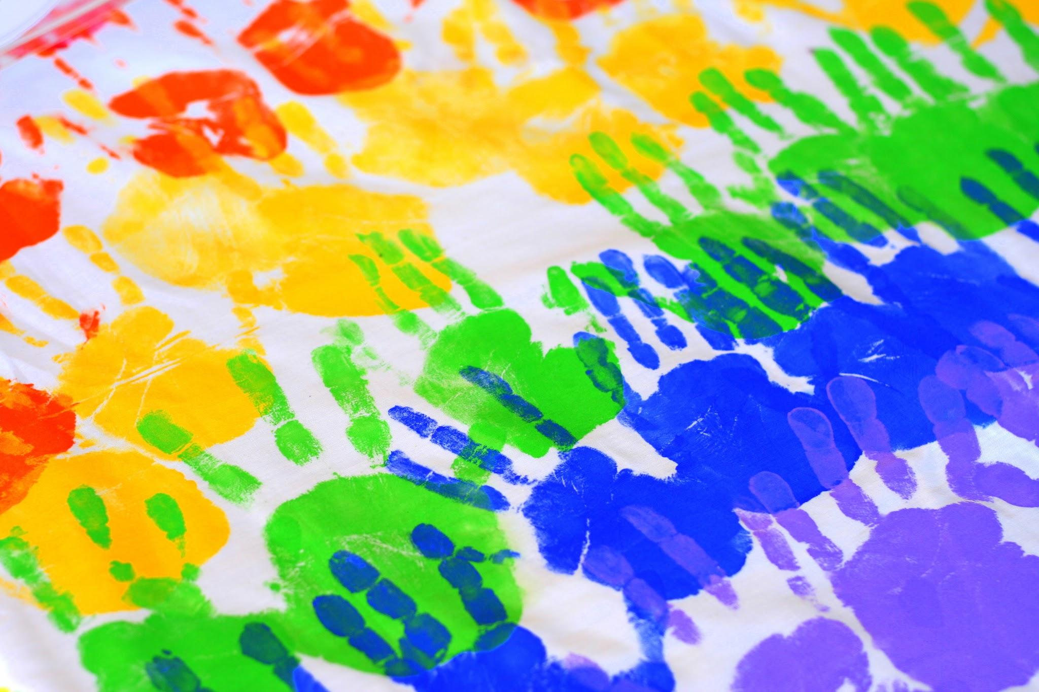 | General Focus  Come into school happily and become aware of daily routines  Ask to go to the toilet  Show preferences for activities and can say why  Look after toys and resources  Self-Regulation Children will be able to follow one step instructions (listening games). Children will recognise different emotions. Children will focus during short whole class activities  Managing Self Children will learn to wash their hands independently.  Building Relationships Children will see themselves as a valuable individual. Children will seek support from adults and gain confidence to speak to peers and adults. | General Focus  Can organise themselves in the environment – classroom  Beginning to have a go at a variety of activities  Will tidy away items safely  Respond to others in conversation and say please and thank you  Self-Regulation Children will talk about how they are feeling and consider others feelings.  Managing Self Children will understand the need to have rules  Building Relationships: Children will begin to develop friendships.
Mathematics  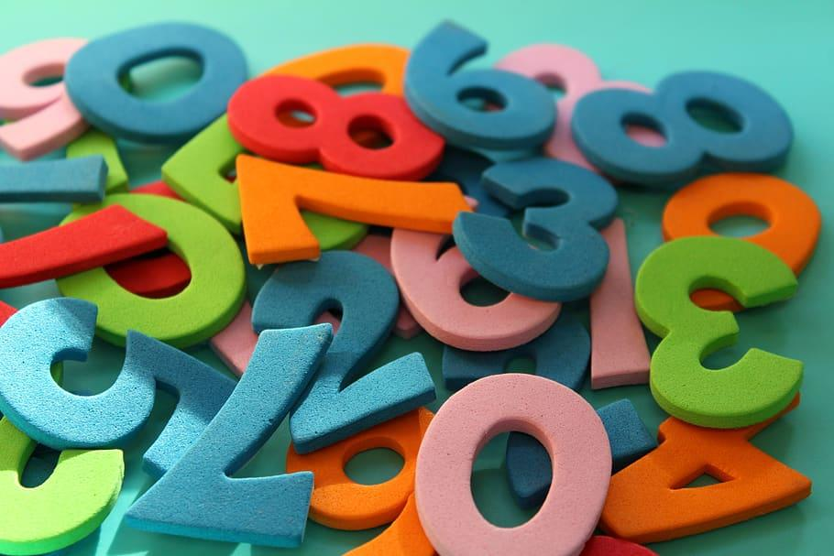 | Mastering Number program  Subitising  Perceptually subitise within 3. Identify subgroups in larger arrangements.  Create their own patterns for numbers within 4. Practise using their fingers to represent quantities which they can subitise. Experience subitising in a range of contexts, including temporal patterns made by sounds. | Subitising  Continue from first half-term Subitise within 5, perceptually and conceptually, depending on the arrangements.
Physical Development   | Gross motor skills  Awareness of Space  Shows basic awareness of space and obstacles with adult guidance.  Introducing Energetic Movement  Moves with some energy in familiar activities with adult support.  • Runs across playground with guidance  • Jumps from low platforms with control  • Participates in simple movement games  Developing Basic Balance and Coordination  • Can stand on one foot briefly with adult prompts  • Passes a ball to a peer with some control  • Walks along a low beam with adult guidance  Fine motor skills  Early Pencil Handling  Begins to use a more refined grip with adult support.  • Uses a static tripod grip with prompting  • Makes simple lines, circles, or letters  • Shows emerging control when drawing or tracing  Exploring small tools  Begins to hold and use small tools with adult support.  • Holds scissors with guidance and makes simple snips  • Paints with some control in guided tasks  • Uses cutlery with prompts to scoop or cut  Early Mark Making  Makes purposeful marks with emerging control  Draws simple shapes or lines with guidance. Begins to stay within boundaries of paper or template. | Gross motor skills  Beginning to Avoid Obstacles  Avoids obstacles and navigates around peers with adult prompts.  Steps over low barriers  • Walk carefully around other children  Improving strength and core stability  Builds strength and core stability; can sustain simple physical activity.  • Climbs onto low climbing equipment with support  • Runs short distances without tripping  • Balances on tiptoes briefly  Building stamina and confidence  Sustains energetic movement with support; begins to coordinate movements.  • Runs around obstacle courses with guidance  • Can skip short distances with adult modelling  • Participates in simple dances  Fine motor skills  Develop control  Holds a pencil with a tripod grip consistently in guided activities.  • Writes letters and shapes with increasing control  • Uses correct pencil posture with occasional prompts  Developing control and accuracy  Holds tools effectively and can control movement with support.  • Cuts along straight or curved lines with guidance  • Paints shapes or patterns with reasonable control  • Uses fork/spoon/chopsticks correctly with occasional prompts  Developing control  Draws shapes and simple objects with reasonable accuracy  Circles, squares, triangles formed clearly. Simple objects like houses, suns, or trees are recognisable.
Understanding the world   | Past and Present (History)  Children will know how they have changed and talk about their immediate family.  People, Culture and Communities (Geography)  Children will discuss their families, where they live and how they travel to school. Children will talk about people who live in other places (family members, friends, explore on a map). They will begin to talk about community.  People, Culture and Communities (RE)  Who is special to me and why?  Families, friends, community.  The Natural World (Science)  Children will understand the terms ‘same’ and ‘different’. Who is the tallest, shortest? Compare feet size. Looking at gender, hair colour, eye colour, skin colour  Children will be able to name body parts. Which part of the body is associated with which sense. Drawing and labelling parts of the body.  Understanding the World (Technology)  Children will know how to use technology to listen to music and stories and the IWB to draw and play games e.g car race, toy shop games on purple mash. | Past and Present (History)  Children will talk about how the past affects the present (Bonfire Night / Remembrance Day). Children will talk about past and present events in their lives and before they were born (prehistoric animals).  People, Culture and Communities (Geography)  Children will know that people celebrate in different ways around the world.  Compare Christmas traditions with another place in the world  People, Culture and Communities (RE)  Special events Advent and Christmas - Why these are special for Christians.  Why Christians think that Jesus was a special baby: the Nativity story.  How the Nativity story is celebrated in school.  New life: How Christians might celebrate the birth of a baby.  Diwali Why Rama and Sita are special to Hindus. How Diwali is celebrated.  The Natural World (Science)  Children will explore and ask questions about the natural world around them (Autumn and animals).  Children can identify and name common animals, identify features of animals. Know that animals are living things. Say how animals are different to humans.  Observe changes across 4 seasons, describe some different types of weather, say how environments are different to each other e.g desert and arctic. How the day is now shorter and the nights are longer.  Understanding the World (Technology)  Children will know how to use age-appropriate software to create images and record sounds and videos - 2paint a picture
Expressive Arts and Design  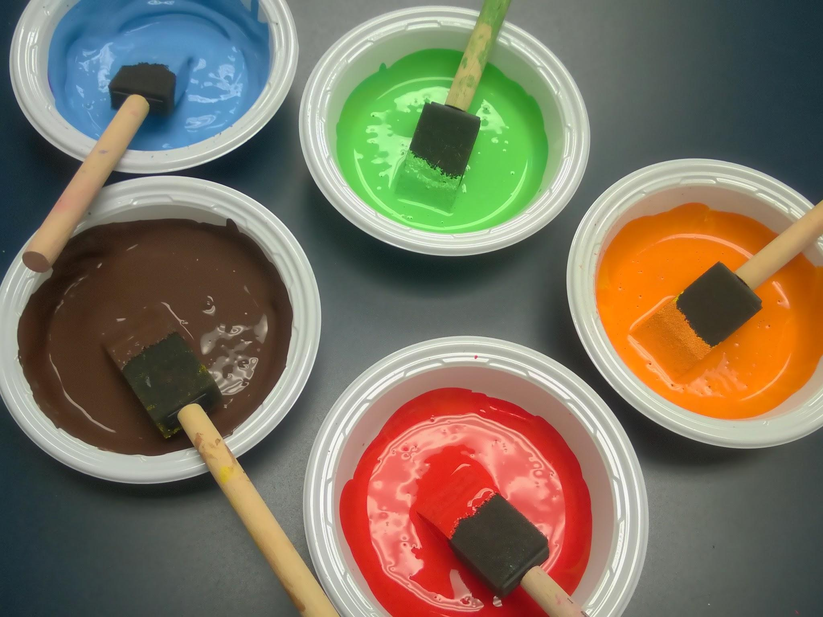 | Art and Design  Begin to use an effective grip of tools  Begin to differentiate colours and name them  Children will experiment mixing with colours.  Children will explore, use and refine a variety of artistic effects to express ideas & feelings.  Children will begin to develop their observational skills by drawing self-portraits.  Simple body prints e.g. hand prints, foot prints  Artists: Kandinsky- feeling and emotions  Being imaginative and expressive  Children will sing and perform nursery rhymes.  They will start to learn to sing in unison and explore finding the beat and clapping it or showing it in their other actions, e.g. marching.  Listen attentively, move to and talk about music, expressing their feelings and responses. | Art and Design  Children will experiment with different textures e.g. creating firework and poppy pictures.  Children will know how to mould clay, e.g. making a Diva lamp.  Children make some independent choices about the resources needed and talk about their creations.  Children to develop their observational drawing skills  Artist: Vincent Van Gogh (sunflowers)  Being imaginative and expressive  Children continue to learn to sing in unison with a focus on Nativity songs.  Rehearse and perform in the Nativity.  Children will develop their roleplay skills when playing alongside their friends, e.g. Santa’s workshop.  Children will learn to explore pitch and mimic the sounds of fireworks.  Children will learn to respond to music and use their imaginations

