
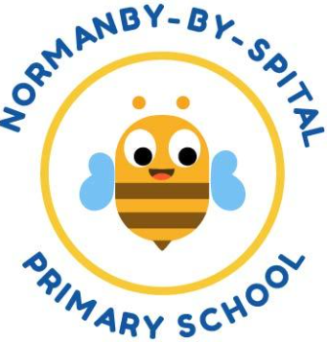
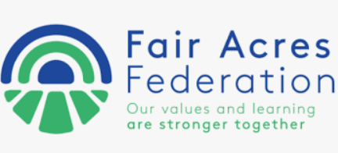
EYFS Curriculum
Overarching Themes | Autumn  September-November |  | Winter  December-February |  | Spring  March-May |  | Summer  June-July
Reception Curriculum | Autumn 1 | Autumn 2 |  | Spring 1 | Spring 2 | Summer 1 |  | Summer 2
Value Focus | Being respectful and considerate | Being part of a community |  | Being fair | Being safe | Being individuals |  | Being the best that I can be
Possible Themes | All about me  Who do you think you are?  Our families  Harvest | Celebrations and light.  Animal Adventures  Autumn |  | Once upon a time  People who help us.  Winter | Superheroes and powers  Growing and changing  Easter | Let's Explore!  Around the world.  Food and farming  Space |  | Beside the seaside  Into the wild  Summer
Key texts | 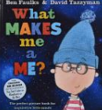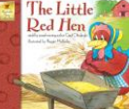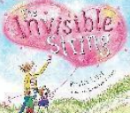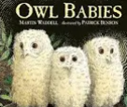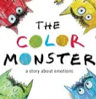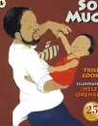 | 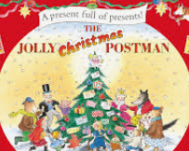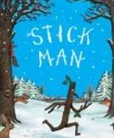  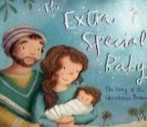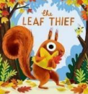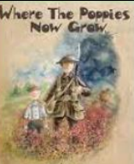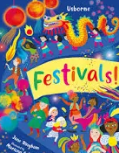 |  | 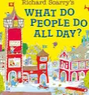  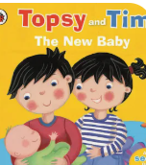  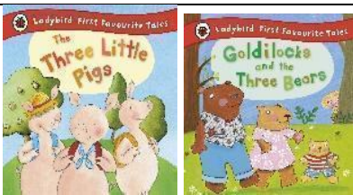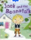 | 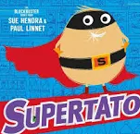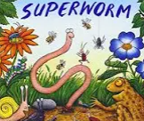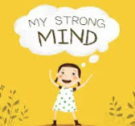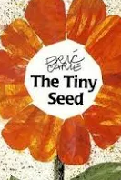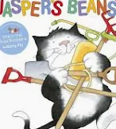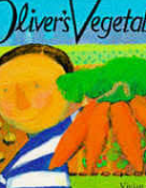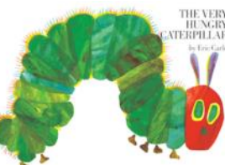  The Very Hungry caterpillar  Oliver’s Vegetables  Jasper’s Beanstalk  Strong mind  Supertato  Superworm  The Tiny seed | 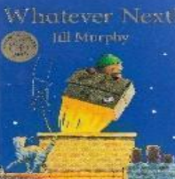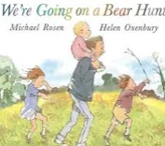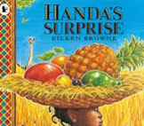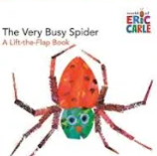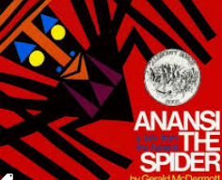  The very busy spider  Anansi the Spider  Whatever Next!  Handa’s Surprise  We’re going on a Bear Hunt |  | 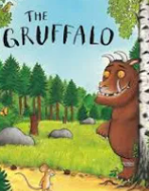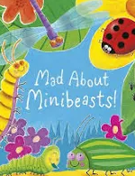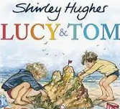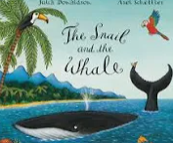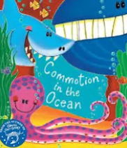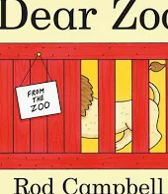  The Gruffalo  Dear Zoo  Commotion in the ocean  Tom and Lucy at the seaside  Mad about minibeasts  Snail and the Whale
Key texts | What makes me me?  The invisible String  Owl babies  The colour monster  So much  Little Red Hen | The leaf thief  Where the poppies grow  The Extra Special Baby  Stick Man  Festivals  The Jolly Christmas Postman |  | The Three Little Pigs  Goldilocks and the Three Bears  Jack and the Beanstalk  Topsy and Tim  What do people do all day?  When we grow up
Trips, visits and moments of magic | All about me box  Harvest Festival visit to church  Home sweet home role play | Diwali wow day  Remembrance day  Bonfire and fireworks  Santa’s workshop  Nativity  Eureka?  Rand Farm Park  Year A Woodside Wildlife Park F and N  Year B- Sundown joint trip F and N  Year C - The Deep  Whole federation? |  | Professional visitors to school  Vet/Doctor/Roleplay/optician role play  Big Garden bird watch  Chinese new year wow day  Pancake day races  Sundown  Safer internet day  Year A - Sherwood Observatory N  Year A F - Lincolnshire Life Museum  Year B-Hall Farm Park - F and N (Rand Farm backup idea)  Year C - Uncle Henry’s F & N | Hall Farm Park  World Book Day  Mothers Day  Plant and grow beans  Make porridge  Easter  caterpillars/butterflies/chicks | Fruit tasting  Uncle Henry’s  Whisby Nature Park  Other cultures wow day  Lincolnshire Life Museum  Wild Pines  Year A -Lincoln Castle F & N  Year B- Wild Pines F and N  Year C - Sherwood Observatory F  Whisby Nature Reserve extra idea |  | Sports day  Fathers Day  Beach/water wow day  Trip to seaside/seal sanctuary  The Deep
Poetry/song | Nursery Rhymes Hello Song | Leaves are falling I’m a Little Hedgehog Song Nativity Songs |  | Pancakes | A Little Seed / Spring Song Poem | A Little Shell / See the Bug |  | In the rock pool / I’m glad to be me

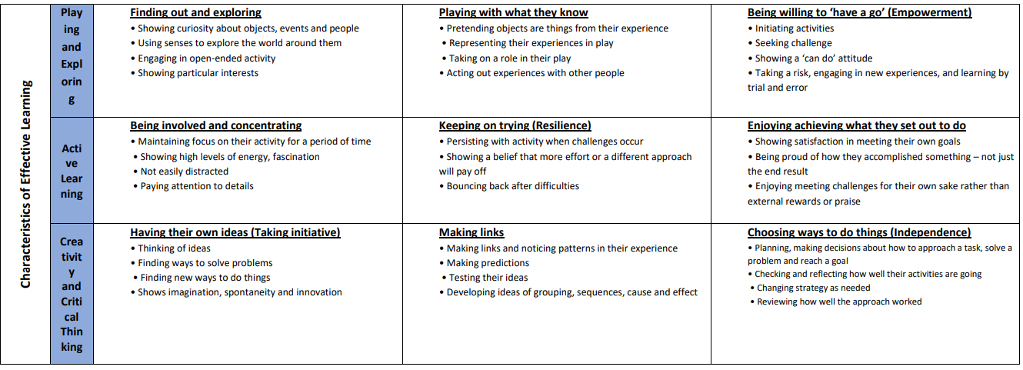

 | Autumn 1 | Autumn 2 | Spring 1 | Spring 2 | Summer 1 | Summer 2
Communication and Language | The development of children’s spoken language underpins all seven areas of learning and development. Children’s back-and-forth interactions from an early age form the foundations for language and cognitive development. The number and quality of the conversations they have with adults and peers throughout the day in a language-rich environment is crucial. By commenting on what children are interested in or doing, and echoing back what they say with new vocabulary added, practitioners will build children's language effectively. Reading frequently to children, and engaging them actively in stories, non-fiction, rhymes and poems, and then providing them with extensive opportunities to use and embed new words in a range of contexts, will give children the opportunity to thrive. Through conversation, story-telling and role play, where children share their ideas with support and modelling from their teacher, and sensitive questioning that invites them to elaborate, children become comfortable using a rich range of vocabulary and language structures.
Communication and Language | Talking points Sharing ‘All About Me’ boxes which include family, baby photos and things which are special to each child. Harvest and autumn Changes | Talking points Role play festivals and celebrations Autumn changes | Talking points Winter changes Asking questions Past, present and future tense | Talking points: Making predictions of what we think will happen. Spring changes | Talking points: Making predictions of what we think will happen. Summer changes | Talking points: What have children enjoyed most about the year/ what they are good at “I am good at…” Summer changes
Communication and Language | Listening, Attention & Understanding Children will be able to understand how to listen carefully and know why it is important. Children will listen carefully to rhymes and songs, paying attention to how they sound. This will continue throughout the year | Listening, Attention & Understanding Children will begin to understand how and why questions. | Listening, Attention & Understanding Children will learn to ask questions to find out more. | Listening, Attention & Understanding Children will retell a story and follow a story prompt without pictures or props to build familiarity and understanding. | Listening, Attention & Understanding Children will be able to understand a question such as who, what, where, when, why and how. | Listening, Attention & Understanding Children will be able to have conversations with adults and peers with back-and-forth exchanges
Communication and Language | Speaking  Children will talk in front of small groups and their teacher offering their own ideas and join in with social phrases. | Speaking Children will use new vocabulary throughout the day. | Speaking Children will engage in non-fiction books and to use new vocabulary in different contexts. Children to continue to use new vocabulary in different contexts. | Speaking Children will talk in sentences using conjunctions e.g. and, because | Speaking Children will use talk to organise, sequence, and clarify thinking, ideas, feelings and events with detail. Children to continue to use new vocabulary in different contexts. | Speaking Children will use talk in sentences using a range of tenses.
Communication and Language | Listening, Attention and Understanding ELG: Listen attentively and respond to what they hear with relevant questions, comments and actions when being read to and during whole class discussions and small group interactions. Make comments about what they have heard and ask questions to clarify their understanding. Hold conversation when engaged in back-and-forth exchanges with their teacher and peers. Speaking ELG: Participate in small group, class and one-to-one discussions, offering their own ideas, using recently introduced vocabulary. Offer explanations for why things might happen, making use of recently introduced vocabulary from stories, non-fiction, rhymes and poems when appropriate. Express their ideas and feelings about their experiences using full sentences, including use of past, present and future tenses and making use of conjunctions, with modelling and
Links to KS1 Readiness | Listening Skills  To listen to others in a range of situations and usually respond appropriately. Following Instruction  To understand instructions with more than one point in many situations. Asking and Answering Questions  To begin to ask questions that are linked to the topic being discussed.  To answer questions on a wider range of topics (sometimes may only be one-word answers).  Drama, performance and confidence To speak clearly in a way that is easy to understand.  To speak in front of larger audiences, e.g. in a class assembly, during a show ‘n’ tell session.  To know when it is their turn to speak in a small group presentation or play performance.  To take part in a simple role play of a known story. |  |  | Vocabulary building and standard English  To use appropriate vocabulary to describe their immediate world and feelings. To think of alternatives for simple vocabulary choices. Speaking for a range of purposes  To organise their thoughts into sentences before expressing them.  To be able to describe their immediate world and environment.  To retell simple stories and recounts aloud.  Participation in a range of discussion To recognise when it is their turn to speak in a discussion.  To recognise that different people will have different responses and that these are as valuable as their own opinions and ideas.

 | Autumn 1 | Autumn 2 | Spring 1 | Spring 2 | Summer 1 | Summer 2
Personal Social and Emotional Development | Children’s personal, social and emotional development (PSED) is crucial for children to lead healthy and happy lives, and is fundamental to their cognitive development. Underpinning their personal development are the important attachments that shape their social world. Strong, warm and supportive relationships with adults enable children to learn how to understand their own feelings and those of others. Children should be supported to manage emotions, develop a positive sense of self, set themselves simple goals, have confidence in their own abilities, to persist and wait for what they want and direct attention as necessary. Through adult modelling and guidance, they will learn how to look after their bodies, including healthy eating, and manage personal needs independently. Through supported interaction with other children they learn how to make good friendships, co-operate and resolve conflicts peaceably. These attributes will provide a secure platform from which children can achieve at school and in later life.
Personal Social and Emotional Development | General Focus  Comes into school happily Aware of daily routines Asks to go to the toilet Shows preferences for activities and can say why Looks after toys and resources | General Focus  Can organise themselves in the environment – classroom Beginning to have a go at a variety of activities Will tidy away items safely Responds to others in conversations Says please and thank you | General Focus Will wait their turn and put their hand up to talk Can line up and walk around school/between activities in single file Play cooperatively Understanding differences | General Focus Is involved in more complex imaginative play with changing roles | General Focus Organising and cooperating with other children. | General Focus Find resolutions without conflict Will offer to help others.
Personal Social and Emotional Development | Self-Regulation Children will be able to follow one step instructions (listening games). Children will recognise different emotions. Children will focus during short whole class activities | Self-Regulation Children will talk about how they are feeling and consider others feelings. | Self-Regulation Children will be able to focus during longer whole class lessons. | Self-Regulation Children will identify and moderate their own feelings socially and emotionally (Train Your Dragon about Feelings). | Self-Regulation Children will be able to control their emotions using a range of techniques. | Self-Regulation Children will be able to follow instructions of three steps or more
Personal Social and Emotional Development | Managing Self Children will learn to wash their hands independently. | Managing Self Children will understand the need to have rules (Train Your Dragon to Follow Rules). NSPCC –Pants | Managing Self Children will begin to show resilience and perseverance in the face of a challenge. Internet safety (Smartie the Penguin) . | Managing Self Children will understand the importance of healthy food choices (Train Your Dragon to Eat Healthy) and importance of sleep (The Bear with Sticky Paws Won’t go to bed). | Managing Self Children will manage their own basic needs independently. | Managing Self Children will show a ‘can do’ attitude.
Personal Social and Emotional Development | Building Relationships Children will see themselves as a valuable individual. Children will seek support from adults and gain confidence to speak to peers and adults. | Building Relationships Children will begin to develop friendships. | Building Relationships Children will be able to use taught strategies to support in turn taking. Stranger Danger | Building Relationships Children will learn to work as a group. | Building Relationships Children will listen to the ideas of other children and agree on a solution and compromise. | Building Relationships Children will have the confidence to communicate with adults around the school.
Suggested texts | 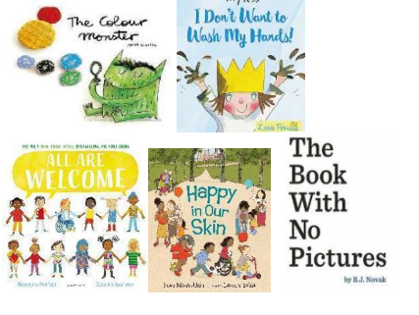 | 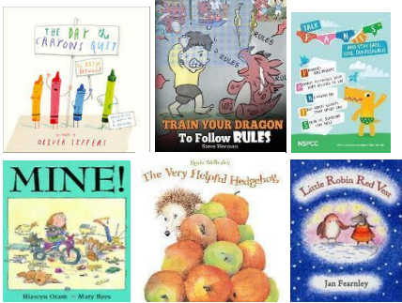 | 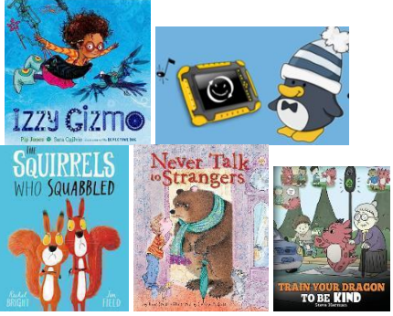 | 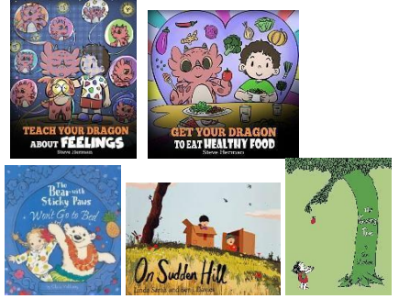 | 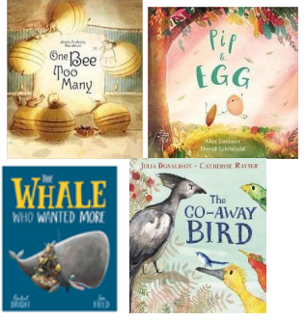 | 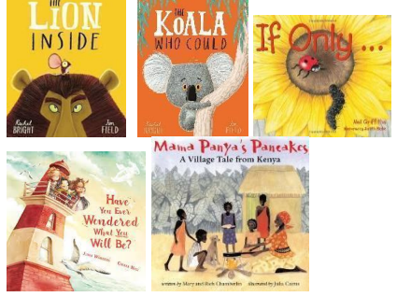
 | Self-Regulation ELG: Show an understanding of their own feelings and those of others, and begin to regulate their behaviour accordingly. Set and work towards simple goals, being able to wait for what they want and control their immediate impulses when appropriate. Give focused attention to what the teacher says, responding appropriately even when engaged in activity, and show an ability. Managing Self ELG: Be confident to try new activities and show independence, resilience and perseverance in the face of challenge. Explain the reasons for rules, know right from wrong and try to behave accordingly. Manage their own basic hygiene and personal needs, including dressing, going to the toilet and understanding the importance of healthy food choices. Building Relationships ELG: Work and play cooperatively and take turns with others. Form positive attachments to adults and friendships with peers. Show sensitivity to their own and to others’ needs
Links to KS1 Readiness | Relationships  Knows right from wrong and can explain why it is important to have boundaries and routines  Working and play cooperatively and taking turns with others  Recognise and show sensitivity to their own and others needs  Recognise similarities and differences between themselves and others  Health and Wellbeing  Managing their own personal hygiene and basic needs  Shows an understanding of their own feelings; and those of others  Being to regulate their behaviour  Shows an understanding of how to stay safe in a range of common situations.  Living in the wider world  Shows care and concern for living things.  Name and describe people who might help us in the local community (police, fire service, doctors and teachers).

 | Autumn 1 | Autumn 2 | Spring 1 | Spring 2 | Summer 1 | Summer 2
Physical Development  Gross Motor Skills  Fine Motor Skills | Physical activity is vital in children’s all-round development, enabling them to pursue happy, healthy and active lives.. By creating games and providing opportunities for play both indoors and outdoors, adults can support children to develop their core strength, stability, balance, spatial awareness, coordination and agility. Gross motor skills provide the foundation for developing healthy bodies and social and emotional wellbeing. Fine motor control and precision helps with hand-eye coordination which is later linked to early literacy. Repeated and varied opportunities to explore and play with small world activities, puzzles, arts and crafts and the practise of using small tools, with feedback and support from adults, allow children to develop proficiency, control and confidence. ELG: Negotiate space and obstacles safely, with consideration for themselves and others.
Physical Development  Gross Motor Skills  Fine Motor Skills | Awareness of Space  Shows basic awareness of space and obstacles with adult guidance.  This could look like:  • Walks around furniture carefully  • Avoids stepping on friends’ feet Introducing Energetic Movement  Moves with some energy in familiar activities with adult support.  This could look like:  • Runs across playground with guidance  • Jumps from low platforms with control  • Participates in simple movement games  Developing Basic Balance and Coordination  This could look like this:  • Can stand on one foot briefly with adult prompts  • Passes a ball to a peer with some control  • Walks along a low beam with adult guidance | Beginning to Avoid Obstacles  Avoids obstacles and navigates around peers with adult prompts.  This could look like this:  Steps over low barriers  • Walks carefully around other children  Improving strength and core stability  Builds strength and core stability; can sustain simple physical activity.  This could look like this:  • Climbs onto low climbing equipment with support  • Runs short distances without tripping  • Balances on tiptoes briefly  Building stamina and confidence  Sustains energetic movement with support; begins to coordinate movements.  This could look like this:  • Runs around obstacle courses with guidance  • Can skip short distances with adult modelling  • Participates in simple dances | Spatial Awareness and Control  Moves safely in open spaces, begins to plan movement.  This could look like:  Skips around peers without contact  • Starts to stop when approaching others  Developing complex coordination  Coordinates movements more consistently with adult guidance.  This could look like this:  • Can throw and catch a ball with some accuracy  • Can hop or skip using alternate feet with support  Developing coordination and variety  Demonstrates more control and variety in energetic movements with adult support.  This could look like this:• Can hop, skip, or jump in sequence  • Participates in short dances or movement routines  • Climbs safely with guidance | Consideration for others  Moves safely, considers other children and adjusts actions with support.  This could look like:  •Slows down near others  • Chooses safe paths through crowded areas  Applying balance and strength in play  Maintains balance and strength in more challenging play with guidance.  This could look like:  • Runs, stops, and changes direction safely  • Climbing and descending low equipment with control  Applying skills independently  Moves energetically and safely in familiar contexts with minimal support.  This could look like:  • Participates in group games independently  • Climbs, hops, skips, and jumps in structured activities | Negotiating challenges  Moves confidently around obstacles and peers in familiar spaces.  This could look like:  • Walks across balance beams carefully  • Navigates indoor/outdoor equipment safely  Refining skills  Can use balance, strength, and coordination in a range of activities.  This could look like:  • Jumps, runs, and climbs safely  • Uses equipment like scooters or bikes with some control  Sustaining energy and precision  Maintains energetic movement for longer periods; movements are controlled.  This could look like:  • Runs, hops, skips, jumps, and climbs safely during longer play sessions  • Participates in dance or movement routines with guidance | ELG  Negotiates space and obstacles safely, with consideration for themselves and others.  This could look like:  •Avoids collisions while running or playing  • Pauses and adjusts when moving near others  • Walks carefully around furniture or equipment  ELG  Demonstrates strength, balance, and coordination when playing.  This could look like  • Runs, jumps, climbs, and balances confidently  • Catches, throws, and kicks balls with accuracy  • Navigates playground equipment safely  ELG  Moves energetically, with control, across a variety of activities.  This could look like:  • Runs, jumps, hops, skips, dances, and climbs safely and confidently  • Sustains movement during group games and structured activities
Physical Development  Gross Motor Skills  Fine Motor Skills | Fine Motor  Early Pencil Handling  Begins to use a more refined grip with adult support.  This could look like:  • Uses a static tripod grip with prompting  • Makes simple lines, circles, or letters  • Shows emerging control when drawing or tracing  Exploring small tools  Begins to hold and use small tools with adult support.  This could look like  • Holds scissors with guidance and makes simple snips  • Paints with some control in guided tasks  • Uses cutlery with prompts to scoop or cut  Early Mark Making  Makes purposeful marks with emerging control  This could look like:  Draws simple shapes or lines with guidance.  Begins to stay within boundaries of paper or template. | Develop control  Holds a pencil with a tripod grip consistently in guided activities.  This could look like this:  • Writes letters and shapes with increasing control  • Uses correct pencil posture with occasional prompts  Developing control and accuracy  Holds tools effectively and can control movement with support.  This could look like:  • Cuts along straight or curved lines with guidance  • Paints shapes or patterns with reasonable control  • Uses fork/spoon/chopsticks correctly with occasional prompts  Developing control  Draws shapes and simple objects with reasonable accuracy  This could look like this:  Circles, squares, triangles formed clearly. Simple objects like houses, suns, or trees are recognisable.. | Building fluency  Holds pencil effectively for longer periods; forms letters and numbers fluently.  This could look like:  • Writes short words or captions with tripod grip  • Draws shapes and patterns steadily  Refining dexterity  Maintains grip and accuracy over longer periods with minimal support.  This could look like:  • Cuts, paints, and uses cutlery steadily  • Can decorate, draw, or cut shapes with reasonable precision  Refining detail  Lines and shapes show increased accuracy; objects identifiable.  This could look like:  Draws people with head, body, arms and legs. Shapes are proportional and recognisable. | Independent Writing Preparation  Uses tripod grip independently in most writing tasks.  This could look like this:  • Writes letters, numbers, and short words with control  • Sustains writing during guided activities  Independent tool use  Uses tools independently in familiar activities.  This could look like:  • Cuts, paints, and uses cutlery with confidence  • Applies skills in simple craft or mealtime activities  Increasing complexity  Draws complex objects/ scenes with care and control.  This could look like:  Combines multiple shapes into one coherent drawing. Maintains neat lines and spacing. | Refining grip and fluency  Maintains correct tripod grip independently, showing good control.  This could look like:  • Writes sentences and simple stories with neat letters  • Draws diagrams or patterns accurately  Mastering range and complexity  Can use a variety of tools effectively in structured tasks.  This could look like this:  Cuts, paints, and manipulates tools for different purposes  • Uses tools with accuracy in craft, cooking, or art activities  Independent drawing  Draws with sustained accuracy and care independently.  This could look like:  Produces recognisable drawings of people, animals or objects. Lines, spacing, and proportion are mostly correct. | ELG  Holds a pencil effectively using tripod grip in almost all cases, ready for fluent writing.  This could look like this:  • Writes sentences, captions, or labels independently  • Draws with control and precision  • Maintains tripod grip for sustained writing  ELG  Uses a range of small tools confidently and effectively.  This could look like this:  • Cuts, paints, and uses cutlery independently with accuracy  • Applies skills in craft, cooking, or creative play  • Chooses appropriate tool for task  ELG  Draws with accuracy and care in most independent tasks. This could look like this:  Lines, shapes, and proportions show control. Drawings recognisable and deliberate
Physical Development  Gross Motor Skills  Fine Motor Skills | Gross Motor ELG: Negotiate space and obstacles safely, with consideration for themselves and others. Demonstrate strength, balance and coordination when playing. Move energetically, such as running, jumping, dancing, hopping, skipping, and climbing.  Fine Motor ELG: Hold a pencil effectively in preparation for fluent writing using the tripod grip in almost all cases. Use a range of small tools, including scissors, paint brushes and cutlery. Begin to show accuracy and care when drawing.
Links to KS1 Readiness | To develop the overall body strength, coordination, balance and agility needed to engage successfully with future physical education.  To use their core muscle strength to achieve a good posture.  To confidently and safely use a range of large and small apparatus indoors and outside, alone and in a group  To combine different movements with ease and fluency.  To develop and refine a range of ball skills including: throwing, catching, kicking, passing, batting, and aiming.  To develop confidence, competence, precision and accuracy when engaging in activities that involve a ball.  To negotiate space and obstacles safely, with consideration for themselves and others.  To confidently and safely use a range of large and small apparatus indoors and outside, alone and in a group.  To revise and refine a range of fundamental movement skills e.g. rolling, crawling, walking, jumping, running, hopping, skipping and climbing.  To combine different movements with ease and fluency.  To use a more fluent style of moving, developing control and grace.  To combine different movements with ease and fluency

 | Autumn 1 | Autumn 2 | Spring 1 | Spring 2 | Summer 1 | Summer 2
Literacy | It is crucial for children to develop a life-long love of reading. Reading consists of two dimensions: language comprehension and word reading. Language comprehension (necessary for both reading and writing) starts from birth. It only develops when adults talk with children about the world around them and the books (stories and non-fiction) they read with them, and enjoy rhymes, poems and songs together. Skilled word reading, taught later, involves both the speedy working out of the pronunciation of unfamiliar printed words (decoding) and the speedy recognition of familiar printed words. Writing involves transcription (spelling and handwriting) and composition (articulating ideas and structuring them in speech, before writing).
Literacy | Comprehension  Children talk about the stories they have heard, recalling some characters and events that happened. Children join in with familiar rhymes and songs. | Comprehension:  Children retell the key events in stories and start to recall facts from non-fiction. Children talk about what has happened in the story so far. | Comprehension  Children to describe the key events in stories or rhymes in some detail, to recall facts from non-fictions texts and predict what might happen next in a story. Children use the language they have heard in stories in their play and discussions. | Comprehension  Children seek familiar texts or stories to re-read in the book area. Children request favourite stories and poems for example during voting for a story. | Comprehension  Children explain what they have read or have read to them. Children retell simple stories using their own words and recently introduced vocabulary. Children share a favourite book with a friend, retelling the story in their own way repeating known phrases from the text. | Comprehension  Children to anticipate – where appropriate – key events in stories. Children offer explanations for why things might happen, making use of recently introduced vocabulary from stories, non-fiction, rhymes and poems when appropriate.
Literacy | Word Reading  Children can hear rhyming words  Little Wandle  Children can hear and read the taught Phase 2 sounds, s a t p i n m d g o c k ck e u r h b f l and start to orally blend.  Recognise tricky words is I the | Word Reading  Children can recognise their own name for self-registration. Little Wandle Letters and Sounds.  Children can hear and read ff ll ss j v w x y z zz qu ch sh th ng nk  • words with –s /s/ added at the end (hats sits)  • words ending –s /z/ (his) and with –s /z/ added at the end (bags)  Recognise tricky words  as and has his her go no to into she he of we me be | Word Reading  Little Wandle  ai ee igh oa oo oo ar or ur ow oi ear air er  • words with double letters  • longer words.  Recognise tricky words  was you they my by all are sure pure | Word Reading  Little Wandle  Review Phase 3  • longer words, including those with double letters  • words with –s /z/ in the middle  • words with –es /z/ at the end  • words with –s /s/ and /z/ at the end  Recognise all tricky words taught so far | Word Reading  Little Wandle  Short vowels with adjacent consonants  • CVCC CCVC CCVCC CCCVC CCCVCC  • longer words and compound words  • words ending in suffixes: –ing, –ed /t/, –ed /id/ /ed/, –est  Recognise Tricky words  said so have like some come love do were here little says there when what one out today | Word Reading  Little Wandle  Phase 3 long vowel graphemes with adjacent consonants  • CVCC CCVC CCCVC CCV CCVCC  • words ending in suffixes: –ing, –ed /t/, –ed /id/ /ed/, –ed /d/ –er, –est  • longer words and compound words  Review all tricky words taught so far.
Literacy | Writing Composition: Children use talk to link ideas, clarify thinking and feelings. They will write their name by copying it from a name mat.  Composition:  Children will know there is a sound/symbol relationship and may copy their name from a name card or try to write it from memory. Begin to write some initial sounds linked to phonics.  Spelling: Children begin orally segmenting sounds in simple words, e.g. c-a-t. and say the initial sounds in most words.  Handwriting:  Practicing patterns  • Horizontal lines, Vertical lines, Wavy lines, Circles (Week 1)  • Up curves, Down curves, Mixed‑height curves, Letter C (Week 2)  • Spirals, Crosses, Turrets, Diagonals (Week 3)  • Zig-zags, Sideways V, Letter X, Triangles (Week 4)  Lowercase Letter formation  Unit 2: Curly letter family • c, a, d (Week 5)  • g, o, q (Week 6)  • e, s, f (Week 7) | Writing Composition: Children will know there is a sound/symbol relationship and may write letters and strings, sometimes in clusters like words. Write initial sounds and begin to segment CVC words and attempt to write them using phonic sounds that have been taught.  Spelling:  Children can write their own name and identify known letters to match initial sounds. The children will begin to write VC and CVC words and labels e.g. c-a-t with support.  Handwriting:  Lowercase Letter formation  Unit 3: Long letter family • l, i, t (Week 8)  • j, u, y (Week 9)  Unit 4: Bouncy letter family • m, n, r (Week 10)  • b, p, h (Week 11)  Unit 5: Zig‑zag letter family • v, w, x (Week 12)  • z, k (Week 13) | Writing Composition: Children segment and write CVC words using phonics sounds that have been taught.  Spelling:  Children can write VC and CVC words using taught graphemes.  Handwriting:  End or start of term Assess and review week Review lower‑case letters as needed (Week 14)  Unit 6: Capital letters  • Cc, Aa, Dd (Week 15)  • Gg, Oo, Qq (Week 16)  • Ee, Ss, Ff (Week 17)  • Ll, Ii, Tt (Week 18)  • Jj, Uu, Yy (Week 19) | Writing Composition: Children segment and write CVVC/CCVC words using phonics sounds that have been taught.  Children can orally compose a caption and hold it in their memory and may attempt to write it (with support).  Spelling:  Children segment to spell words independently using taught graphemes. Children can also spell some HFW independently, e.g the, to etc.  Handwriting:  Assess and review week (Week 20 – before or after half‑term)  • Mm, Nn, Rr (Week 21)  • Bb, Pp, Hh (Week 22)  • Vv, Ww, Xx (Week 23)  • Zz, Kk (Week 24)  Little Wandle Handwriting End or start of term Assess and review week Review capital letters as needed (Week 25) | Writing Composition: Children can write short captions independently. They will also begin to write a simple sentence with support.  Spelling: Children can spell words by drawing on knowledge of known grapheme correspondences. Children make phonetically plausible attempts when writing more complex unknown words.  Handwriting:  Unit 7: Digraphs and trigraphs  • ff, ll, ss (Week 26)  • zz, ck, qu (Week 27)  • ch, sh, th (Week 28) • ng, nk, ai (Week 29)  • ee, igh, oa (Week 30) | Writing Composition: Children continue developing the ability to write captions and short sentences independently with finger spaces. They can read their own sentences and so can teachers.  Spelling: Children can spell words by drawing on knowledge of known grapheme correspondences. Children make phonetically plausible attempts when writing more complex unknown words. Children can also spell more HFW independently, e.g. he, she, we, be, me.  Handwriting: Assess and review week Week 31 – before or after half‑term)  • oo, ar, or (Week 32)  • ur, ow, oi (Week 33)  • ear, air, er  plus Assess and review (Week 34)  Week 34 onwards Assess and review all letters as needed.
Literacy | Comprehension ELG: Demonstrate understanding of what has been read to them by retelling stories and narratives using their own words and recently introduced vocabulary. Anticipate – where appropriate – key events in stories. Use and understand recently introduced vocabulary during discussions about stories, non-fiction, rhymes and poems and during role-play.  Word Reading ELG: Say a sound for each letter in the alphabet and at least 10 digraphs. Read words consistent with their phonic knowledge by sound-blending. Read aloud simple sentences and books that are consistent with their phonic knowledge, including some common exception words.  Writing ELG: Write recognisable letters, most of which are correctly formed. Spell words by identifying sounds in them and representing the sounds with a letter or letters. Write simple phrases and sentences that can be read by others.
Links to KS1 Readiness | Learning to Read  Developing phonemic knowledge through Little Wandle Letters and Sounds Phonics and other phonic opportunities  Developing a knowledge of stories including rhyme and identify the rhyming words within them. Developing their skills and abilities to comprehend within familiar stories, and from pictures in illustrated stories.  Reading to Learn  Developing their skills and abilities in retelling familiar stories.  Recognising that books have information that helps them to learn.  Reading for Enjoyment  Routinely accessing picture books and stories.  Listening to others expressively tell stories.  Learning that stories and books can put them in imaginary worlds full of adventure and excitement. |  |  | Learning to Write  Holds pencils, pens and other marking making tools appropriately so that they can make marks in an increasingly controlled way.  To explore language and vocabulary in stories and the environment, and begin to use them accurately when talking.  Writing to Learn  Write independently to communicate their thoughts and ideas about their lived experiences.  Write words and sentences to help them to remember what they have done.  Writing for Enjoyment  Have opportunities to make marks, and then to write about things in the world around them that they are inspired to write about.

 | Autumn 1 | Autumn 2 | Spring 1 | Spring 2 | Summer 1 | Summer 2
Mathematics  Number and numerical patterns (NCETM Mastering Number)  Shape, space, measure | Developing a strong grounding in number is essential so that all children develop the necessary building blocks to excel mathematically. Children should be able to count confidently, develop a deep understanding of the numbers to 10, the relationships between them and the patterns within those numbers. By providing frequent and varied opportunities to build and apply this understanding - such as using manipulatives, including small pebbles and tens frames for organising counting - children will develop a secure base of knowledge and vocabulary from which mastery of mathematics is built. In addition, it is important that the curriculum includes rich opportunities for children to develop their spatial reasoning skills across all areas of mathematics including shape, space and measures. It is important that children develop positive attitudes and interests in mathematics, look for patterns and relationships, spot connections, ‘have a go’, talk to adults and peers about what they notice and not be afraid to make mistakes.
 | Subitising  Perceptually subitise within 3. Identify subgroups in larger arrangements.  Create their own patterns for numbers within 4. Practise using their fingers to represent quantities which they can subitise. Experience subitising in a range of contexts, including temporal patterns made by sounds. | Subitising  Continue from first half-term Subitise within 5, perceptually and conceptually, depending on the arrangements. | Subitising  Increase confidence in subitising by continuing to explore patterns within 5, including structured and random arrangements. Explore a range of patterns made by some numbers greater than 5, including structured patterns in which 5 is a clear part.  Experience patterns which show a small group and ‘1 more’ Continue to match arrangements to finger patterns. | Subitising  Explore symmetrical patterns, in which each side is a familiar pattern, linking this to ‘doubles’ | Subitising  Continue to practise increasingly familiar subitising arrangements, including those which expose ‘1 more’ or ‘doubles’ patterns.  Use subitising skills to enable them to identify when patterns show the same number but in a different arrangement, or when patterns are similar but have a different number.  Subitise structured and unstructured patterns, including those which show numbers within 10, in relation to 5 and 10 Be encouraged to identify when it is appropriate to count and when groups can be subitised. | In this half-term, the children will consolidate their understanding of concepts previously taught through working in a variety of contexts and with different numbers.
 | Cardinality, ordinality and counting  Relate the counting sequence to cardinality, seeing that the last number spoken gives the number in the entire set. Have a wide range of opportunities to develop their knowledge of the counting sequence, including through rhyme and song. Have a wide range of opportunities to develop 1:1 correspondence, including by coordinating movement and counting. Have opportunities to develop an understanding that anything can be counted, including actions and sounds. Explore a range of strategies which support accurate counting. | Cardinality, ordinality and counting  Continue to develop their counting skills Explore the cardinality of 5, linking this to dice patterns and 5 fingers on 1 hand Begin to count beyond 5 Begin to recognise numerals, relating these to quantities they can subitise and count. | Cardinality, ordinality and counting  Continue to develop verbal counting to 20 and beyond. Continue to develop object counting skills, using a range of strategies to develop accuracy. Continue to link counting to cardinality, including using their fingers to represent quantities between 5 and 10. Order numbers, linking cardinal and ordinal representations of number. | Cardinality, ordinality and counting  Continue to consolidate their understanding of cardinality, working with larger numbers within 10 Become more familiar with the counting pattern beyond 20. | Cardinality, ordinality and counting  Continue to develop verbal counting to 20 and beyond, including counting from different starting numbers Continue to develop confidence and accuracy in both verbal and object counting. | In this half-term, the children will consolidate their understanding of concepts previously taught through working in a variety of contexts and with different numbers.
 | Composition  See that all numbers can be made of 1s.  Compose their own collections within 4. | Composition  Explore the concept of ‘wholes’ and ‘parts’ by looking at a range of objects that are composed of parts, some of which can be taken apart and some of which cannot.  Explore the composition of numbers within 5. | Composition  Continue to explore the composition of 5 and practise recalling ‘missing’ or ‘hidden’ parts for 5. Explore the composition of 6, linking this to familiar patterns, including symmetrical patterns.  Begin to see that numbers within 10 can be composed of ‘5 and a bit’ | Composition  Explore the composition of odd and even numbers, looking at the ‘shape’ of these numbers.  Begin to link even numbers to doubles.  Begin to explore the composition of numbers within 10. | Composition  Explore the composition of 10. | In this half-term, the children will consolidate their understanding of concepts previously taught through working in a variety of contexts and with different numbers.
 | Comparison  Understand that sets can be compared according to a range of attributes, including by their numerosity. Use the language of comparison, including ‘more than’ and ‘fewer than’ Compare sets ‘just by looking’ | Comparison  Compare sets using a variety of strategies, including ‘just by looking’, by subitising and by matching Compare sets by matching, seeing that when every object in a set can be matched to one in the other set, they contain the same number and are equal amounts. | Comparison  Continue to compare sets using the language of comparison, and play games which involve comparing sets Continue to compare sets by matching, identifying when sets are equal Explore ways of making unequal sets equal. | Comparison  Compare numbers, reasoning about which is more, using both an understanding of the ‘how many ness’ of a number, and its position in the number system. | Comparison  Order sets of objects, linking this to their understanding of the ordinal number system. | In this half-term, the children will consolidate their understanding of concepts previously taught through working in a variety of contexts and with different numbers.
 | Make simple patterns. Introduce and recall 2D shape names. | Compose and decompose shapes so that children recognise a shape can have other shapes within it, just as numbers can. Introduce 3D shape names. | Select, rotate and manipulate shapes to develop spatial reasoning skills. | Compare length, weight and capacity. | Continue, copy and create repeating patterns. | Compare length, weight and capacity.
Number ELG: Have a deep understanding of number to 10, including the composition of each number;
Subitise (recognise quantities without counting) up to 5;
Automatically recall (without reference to rhymes, counting or other aids) number bonds up to 5 (including subtraction facts) and some number bonds to 10, including double facts.

Numerical Patterns ELG: Verbally count beyond 20, recognising the pattern of the counting system; compare quantities up to 10 in different contexts, recognising when one quantity is greater than, less than or the same as the other quantity; explore and represent patterns within numbers up to 10, including evens and odds, double facts and how quantities can be distributed equally.
Links to KS1 Readiness | Number  To count confidently  To show a deep understanding of numbers up to 10  To match numerals with a group of objects to show how many there are (up to 10)  To be able to identify relationships and patterns between numbers up to 10  To show an awareness that numbers are made up of smaller numbers, exploring partitioning in different ways  To add and subtract one in practical activities  Measurement  To measure themselves and everyday objects using a mixture of non-standard and standard measurements  To develop spatial reasoning using measures  To begin to order and sequence events using everyday language related to time  To begin to measure time with timers (e.g. digital stopwatches and sand timers) and calendars  To explore the use of different measuring tools in everyday experiences and play |  |  | Geometry  To use informal language (e.g. heart-shaped, hand-shaped) and some mathematical language to describe shapes around them  To use spatial language, including following and giving directions, using relative terms  To develop spatial reasoning with shape and space  To compose and decompose shapes, and understanding which shapes can combine together to make another shape.

 | Autumn 1 | Autumn 2 | Spring 1 | Spring 2 | Summer 1 | Summer 2
Understanding the world | Understanding the world involves guiding children to make sense of their physical world and their community. The frequency and range of children’s personal experiences increases their knowledge and sense of the world around them – from visiting parks, libraries and museums to meeting important members of society such as police officers, nurses and firefighters. In addition, listening to a broad selection of stories, non-fiction, rhymes and poems will foster their understanding of our culturally, socially, technologically and ecologically diverse world. As well as building important knowledge, this extends their familiarity with words that support understanding across domains. Enriching and widening children’s vocabulary will support later reading comprehension.
Understanding the world | Past and Present (History)  Children will know how they have changed and talk about their immediate family. | Past and Present (History)  Children will talk about how the past affects the present (Bonfire Night / Remembrance Day). Children will talk about past and present events in their lives and before they were born (prehistoric animals). | Past and Present (History)  Children will talk about different jobs and people who help us in society. Children will know about the past through settings and characters.  Local area-how the local area has changed over time, using photos and books. | Past and Present (History)  Children will talk about what they can see in pictures of the past. Children will know some similarities and differences between things in the past and now (kitchen/house – Goldilocks and Three Bears and The Three Little Pigs). | Past and Present (History)  Children will talk about what they can see in pictures of the past. Children will know some similarities and differences between things in the past and now (farming).  Children will talk about how the past affects the present (Nelson Mandela). | Past and Present  (History) Children will talk about the seaside in the past. Children will know some similarities and differences between the seaside in the past and now.
Understanding the world | People, Culture and Communities (Geography)  Children will discuss their families, where they live and how they travel to school. Children will talk about people who live in other places (family members, friends, explore on a map). They will begin to talk about community. | People, Culture and Communities (Geography)  Children will know that people celebrate in different ways around the world.  Compare Christmas traditions with another place in the world (Norway, France) | People, Culture and Communities (Geography)  Children will know about people who help us within the community.  Children will discuss features of the local area.  School or village | People, Culture and Communities (Geography)  Children will know about features of the immediate environment, and draw information from a simple map.  Make comparisons between village and town/city. | People, Culture and Communities (Geography)  Children will know about the importance of farming for Lincolnshire.  Children will recognise some similarities and differences between life in this country and life in other countries. | People, Culture and Communities (Geography)  Children will recognise some similarities and differences between the reception and year 1 classrooms/conservatory
Understanding the world | People, Culture and Communities (RE)  Who is special to me and why?  Families, friends, community. | People, Culture and Communities (RE)  Special events  Advent and Christmas.  Why these are special for Christians.  Why Christians think that Jesus was a special  baby: the Nativity story.  How the Nativity story is celebrated in  school.  New life: How Christians might celebrate the  birth of a baby.  Diwali  Why Rama and Sita are special to Hindus.  How Diwali is celebrated in school. | People, Culture and Communities (RE)  Easter  How we can see Easter around us.  Signs and symbols.  What Christians remember at Easter  The Easter story and what it means to Christians. | People, Culture and Communities (RE)  Holi  The stories of Krishna, Holika and Prahlad.  How Hindus celebrate Holi. | People, Culture and Communities (RE)  The idea of special and sacred  What makes something special.  What makes objects, clothes and places special.  Why are some of these things considered sacred?  What we can see in a church and a mandir. | People, Culture and Communities (RE)  The idea of special and sacred  Visit * to a church and mandir: Important objects,  pictures and symbols.  *or through virtual tours, video clips, images, etc.
Understanding the world | The Natural World (Science)  Year A  Children will understand the terms ‘same’ and ‘different’. Who is the tallest, shortest? Compare feet size. Looking at gender, hair colour, eye colour, skin colour  (PC:R, G)  Year B Children will be able to name body parts. Which part of the body is associated with which sense. Drawing and labelling parts of the body. | The Natural World (Science)  Children will explore and ask questions about the natural world around them (Autumn).  Year A: Animals  Children can identify and name common animals, identify features of animals. Know that animals are living things. Say how animals are different to humans,  Year B: Observe changes across 4 seasons, describe some different types of weather, say how environments are different to each other e.g desert and arctic  .How the day is now shorter and the nights are longer.  Know the difference between light and dark. Experiment with shadows.  Identify rainbows. | The Natural World (Science)  Children will talk about features of the environment and describe what they see, hear and feel whilst outside.  Children will notice and talk about important changes in the world and how things can change from one state to another, such as water freezing.  Floating and sinking-Gingerbread  Jack and beanstalk - grow plants - how to care for a seed | The Natural World (Science)  Children will know how to sort and group materials and resources and talk about how they are similar or different. E.g changing to materials such as tearing, twisting, scrunching, mixing, gluing. | The Natural World (Science)  Children will make observations about plants discussing similarities and differences. Know the basic parts of a plant e.g leaf, stem, flower, root. Children will know some important processes and changes in the natural world. Children will recognise some environments that are different from the one in which they live.  Space: know that we live on planet Earth, the light in the sky is called the sun and it is dangerous to look at it. To read stories and rhymes about stars/space. To know about light and dark.  To know we can’t live in space but astronauts can visit it. (Astro Girl) | The Natural World (Science)  Children will make observations about plants and animals discussing similarities and differences e.g lifecycles  Food groups/lifecycles
Understanding the world | Understanding the World (Technology)  Children will know how to use a tonie box to listen to music and stories and the IWB to draw and play games e.g car race, toy shop games on purple mash. | Understanding the World (Technology)  Children will know how to use age appropriate software to create images and record sounds and videos - 2paint a picture | Understanding the World (Technology)  Children will begin to learn about keeping safe - Internet Safety | Understanding the World (Technology)  Children will know how to input simple instructions to technological toys, including floor robots. (beebots) | Understanding the World (Technology)  Early computing skills -Purple Mash
ELG | Past and Present ELG:  Talk about the lives of the people around them and their roles in society. Know some similarities and differences between things in the past and now, drawing on their experiences and what has been read in class. Understand the past through settings, characters and events encountered in books read in class and storytelling.  People, Culture and Communities ELG: Describe their immediate environment using knowledge from observation, discussion, stories, non-fiction texts and maps. Know some similarities and differences between different religious and cultural communities in this country, drawing on their experiences and what has been read in class. Explain some similarities and differences between life in this country and life in other countries, drawing on knowledge from stories, non-fiction texts and (when appropriate) maps.  The Natural World ELG: Explore the natural world around them, making observations and drawing pictures of animals and plants. Know some similarities and differences between the natural world around them and contrasting environments, drawing on their experiences and what has been read in class. Understand some important processes and changes in the natural world around them, including the seasons and changing states of matter.
Links to KS1 Readiness | History  Using Language associated with the past  Use words associated with the past including yesterday, last week, last year.  Use past tense when speaking about things that happened in the past.  Remembering and discussing their own lives  Share their memories of significant events in their own lives.  Talk about things that have changed.  Begin to put these events in order.  Talking about things they have done with people special to them  Share their memories of things that they have done with people that are special to them including friends, family, classmates and teachers.  Begin to put events in order.  Recognising Chronology within stories  Talk about the order of events in a range of familiar stories.  Recognise language in stories that show the story happened in the past. |  |  | RE  Believing  To know that different people have different faiths  To know that some stories come from different holy books, and to express ideas in response to those stories  Living  To know that different people have different times of celebration  To understand that different people have different ways of celebrating major events To know that people of all faiths can and do live well alongside each other  To enjoy joining in with family customs and routines  To be able to express some of their own families’ customs and traditions  Expressing  To know that different people have a range of different ways of showing their beliefs, including prayers and worship To know about the similarities and differences between themselves and others, and among families, communities, cultures and traditions
Links to KS1 Readiness | Geography  Locational Knowledge  Know where they live  Know how they travel to school  Knowledge of Places  Talk about some of the differences they notice when they are in different places  Talk about places when looking at books and watching tv/videos  Talking about places they have been to  Talk about places in stories  Using language that relates to place  Human and Physical Geographical Knowledge  Recognise elements of their environment that are manmade and natural  Using Maps  Make maps from stories  Follow simple maps in play |  |  | Science  Working Scientifically  To feel confident to answer simple questions about observable properties of objects and people, animals and plants around them  To compare objects in their environment and talk about similarities and differences To ask questions about the world around them, and seek to find their own answers Plants  To know what a plant is  To know what a flower is  To know where you see plants  To describe different plants and flowers  Animals including Humans  To know what an animal is To recognise and name a variety of different animals  To know the names of different body parts of humans and animals they have experience of  Everyday Materials  To recognise that different everyday objects are made from different materials  To describe how different objects, look and feel  Seasonal Change  To know about different types of weather  To observe changes in trees and plants as the seasons progress

 | Autumn 1 | Autumn 2 | Spring 1 | Spring 2 | Summer 1 | Summer 2
Expressive Art and Design | The development of children’s artistic and cultural awareness supports their imagination and creativity. It is important that children have regular opportunities to engage with the arts, enabling them to explore and play with a wide range of media and materials. The quality and variety of what children see, hear and participate in is crucial for developing their understanding, self-expression, vocabulary and ability to communicate through the arts. The frequency, repetition and depth of their experiences are fundamental to their progress in interpreting and appreciating what they hear, respond to and observe.
Expressive Art and Design | Art and Design:  Begin to use an effective grip of tools  Begin to differentiate colours and name them  Children will experiment mixing with colours.  Children will explore, use and refine a variety of artistic effects to express their ideas and feelings.  Children to begin to  develop their observational skills by drawing self-portraits.  Simple body prints e.g. hand prints, foot prints  Artist: Todd Parr.  Alexander Calder (wire portraits)  Kandinsky- feeling and emotions | Art and Design:  Children will experiment with different textures e.g. creating firework and poppy pictures.  Children will know how to mould clay, e.g. making a Diva lamp.  Children make some independent choices about the resources needed and talk about their creations.  Children to develop their observational drawing skills  Artist: Vincent Van Gogh (sunflowers) | Art and design:  Children will safely explore different techniques for joining materials. Eg making the house of the three little pigs  Children will use wax and wash to create winter scenes.  To learn to design for a purpose e.g make props to go with their traditional tales costumes.  Design make an evaluate an super vegetable (Supertato)  Artist: Claude Monet (Magpie) | Art and Design:  Children will further develop their colour mixing skills to produce different shades.  Children use natural resources to create images in the environment.  Make rubbings showing a range of texture and patterns.  Children to develop their observational skills by drawing pictures of spring flowers.  Vegetable printing  Artist: Andy Goldsworthy | Art and Design:  Children will learn to design for a purpose, e.g. a farm before starting to create.  Take print from object: leaf, hand, onion, feet, junk, bark, modelling, clay. Produce simple pictures by printing objects.  Imprint onto a range of textures – newspaper, coloured paper, plain paper, into clay and dough.  Artist: Yayoi Kusama (printing) | Art and Design  Children will create under water colour pictures using water colour paint.  Children will experiment with clay and create models (animals from the wild, lifecycles)  Artist: Lowry/Alfred Wallis
Expressive Art and Design | Being imaginative and expressive  Children will sing and perform nursery rhymes.  They will start to learn to sing in unison and explore finding the beat and clapping it or showing it in their other actions, e.g. marching.  Listen attentively, move to and talk about music, expressing their feelings and responses. | Being imaginative and expressive  Children continue to learn to sing in unison with a focus on Nativity songs.  Rehearse and perform in the KS1 Nativity.  Children will develop their roleplay skills when playing alongside their friends, e.g. Santa’s workshop.  Children will learn to explore pitch and mimic the sounds of fireworks.  Children will learn to respond to music and use their imaginations | Being imaginative and expressive  Children will be taught to find the pulse in a range of songs and explore the sounds of different instruments.  Children will explore and engage in music making and dance, performing solo or in groups.  Children will create narratives based around stories.  PE:Dance | Being imaginative and expressive  Children will continue to find the pulse in a song and begin to use percussion instruments to explore rhythm. | Being imaginative and expressive  Children will learn to find the rhythm in the spoken word.  Children will learn about music from other cultures. | Being imaginative and expressive  Children will appreciate the music and describe how it makes them feel and what they can imagine while listening.  Children will invent their own narratives, stories and poems
Expressive Art and Design | Creating with Materials ELG: Safely use and explore a variety of materials, tools and techniques, experimenting with colour, design, texture, form and function. Share their creations, explaining the process they have used. Make use of props and materials when role playing characters in narratives and stories. Being Imaginative ELG: Invent, adapt and recount narratives and stories with peers and their teacher. Sing a range of well-known nursery rhymes and songs. Perform songs, rhymes, poems and stories with others, and (when appropriate) try to move in time with music
Links to KS1 Readiness | Art  Using materials  Hold tools like pencils, paint brushes, scissors with increasing precision  Experiment with using different everyday and art materials to explore colour, texture and form Drawing, painting and sculpture  To explore their ideas and imagination by creating drawings, paintings and sculptures.  To explore creating designs and art work on a range of scales.  Exploring techniques.  To explore a range of techniques to draw, paint, print and sculpt to help them create art work. Comparing and evaluating work  Recognising and exploring the colour, patterns and shapes in other artist’s work.  Expressing opinions and feelings in response to their own art work and other artist’s work.  Sharing their work with other people, talking about what they have created. |  |  | Music  Vocalising and Singing  To join in with singing familiar songs and rhymes.  To make up songs and rhymes of their own.  To match the pitch of their voice to the pitch of the song they are singing.  Hearing and Listening  To listen to live and recorded music, hearing lyrics, rhymes and instruments.  To listen to live and recorded music, hearing changes in tempo, rhythm and dynamics. To respond to live and recorded music, expressing how it makes them feel, and what it makes them imagine.  Moving and Dancing  To respond to music, including individual instruments with movement and dance  To match movements to the rhythm and pulse of a piece of music  Exploring and Playing  To explore the range of sounds made by different instruments.  To use a range of percussive instruments to enhance songs and rhymes.  To know the names of instruments that they have explored and used

