Book recommendation by Dragon Class
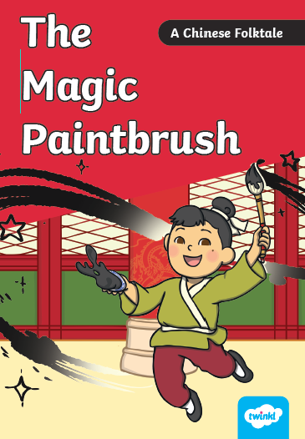
Ma Liang is a kind young boy with a passion for drawing, but he is too poor to afford a paintbrush of his own. One night, his life changes forever when he is gifted a magic paintbrush in a dream. To his amazement, anything he paints with the brush comes to life—from food for the hungry to water for dry fields!
However word of this incredible power soon reaches the ears of a greedy rich man who wants the brush for his own selfish gain.
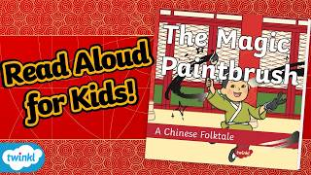
Dragon Class have thoroughly enjoyed this story from Chinese culture. It has helped us learn about China and we have used this book to write our own versions of the magic paintbrush.

Here is a link to a read aloud version of this book https://www.youtube.com/watch?v=iz7rWI3Slxk

Other versions of this traditional folk tale from China include
