Faldingworth Primary School Reception, Year 1 & Year 2 Curriculum Framework – Dragon Class Year 2025 - 2026
Theme |  | Let’s go to China
Spring Terms |  | Term 3 | Term 4
Knowledge and understanding of the world | Science | Everyday Materials and their properties | Everyday Materials and their uses
Knowledge and understanding of the world | ICT | Coding, Online safety | Data Explorers
Knowledge and understanding of the world | History |  | History of Transport
Knowledge and understanding of the world | Geography | Let’s go to China
Knowledge and understanding of the world | DT | 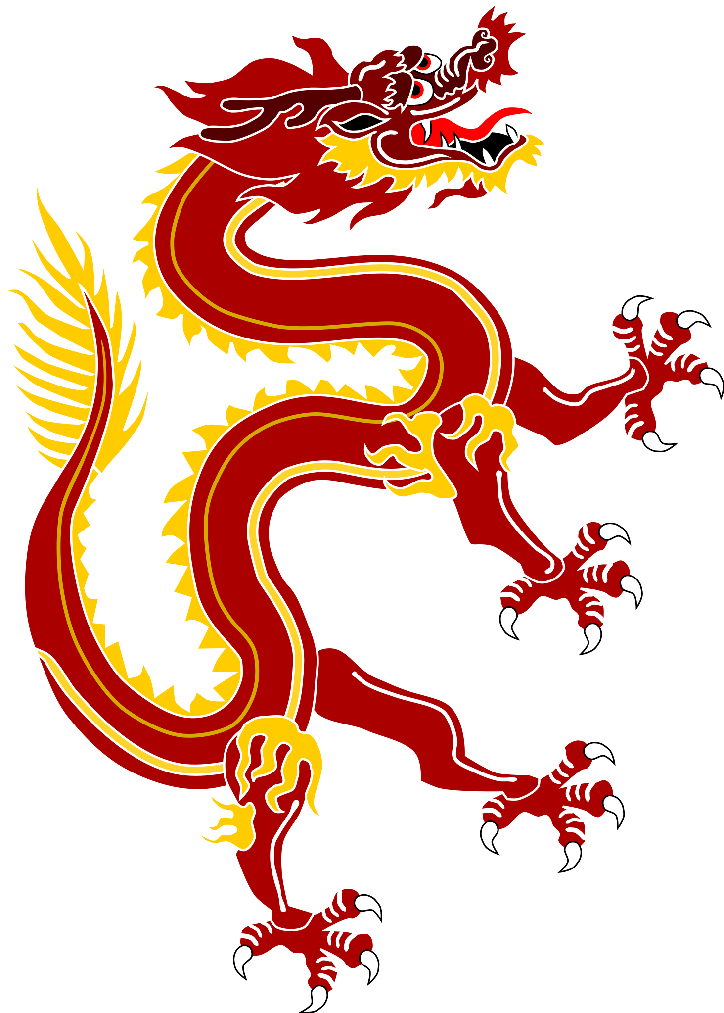 | Moving Pictures
Personal, social and emotional development | RE | Islam - Being Human | Islam - Life journey
Personal, social and emotional development | PSHE | Living in the wider world | Relationships
Personal, social and emotional development | Role Play | Chinese restaurant and airport
Physical development | PE | Gymnastics  Dance | 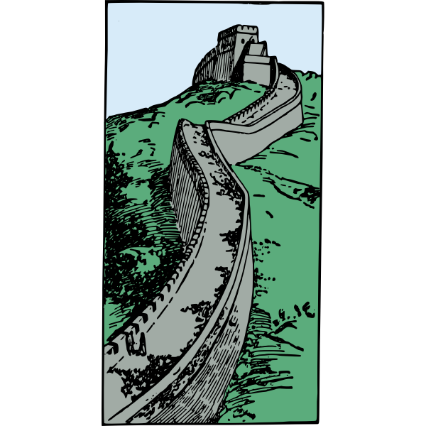  Invasion skills  Bat and Ball games
Creative Development | Art | Collage
Creative Development | Music | Magical Musical Aquarium - classical music inspired sounds and songs
Communication, Language and Literacy | English | Y1/2  Stories from Other Cultures, Information texts  FS News and drawing club | Y1/2  Stories from Other Cultures, Information texts, recounting personal experiences  FS News and drawing club
Mathematical Development | Maths | EYFS Numbers to 8, Mass & Capacity, Length & Height, Time  Year 1 and 2 Addition and Subtraction within 100, Multiplication and Division | EYFS Numbers to 10, Bonds to 10, Patterns, 3D shapes  Year 1 and 2 Multiplication and Division, Length & Height, Statistics

