Book recommendation

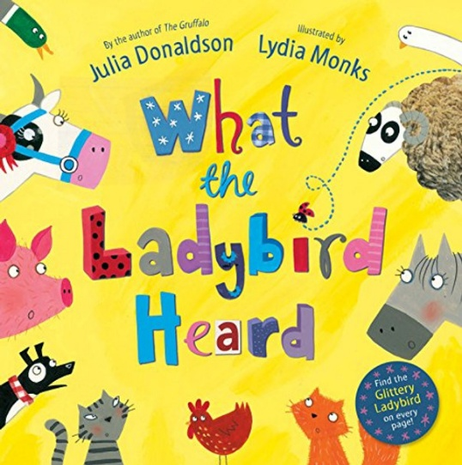

What the Ladybird Heard
by Julia Donaldson
Suitable for 4 to 7 years

The story features two crafty robbers, Hefty Hugh and Lanky Len, who plan to steal the farmer's prize cow. They don't realize that the quietest creature on the farm, a little ladybird, has overheard their plan and devised a clever way to stop them.
It shows that even the smallest and quietest individuals can be brave and make a big difference.
The book includes lively rhyming verse and vibrant illustrations.

