
Faldingworth Primary School Reception, Year 1 and 2 Curriculum Framework – Dragon Class Year 2025-2026
Theme |  | Animals around the World
Autumn Terms |  | Term 1 | Term 2
Knowledge and understanding of the world | Science | 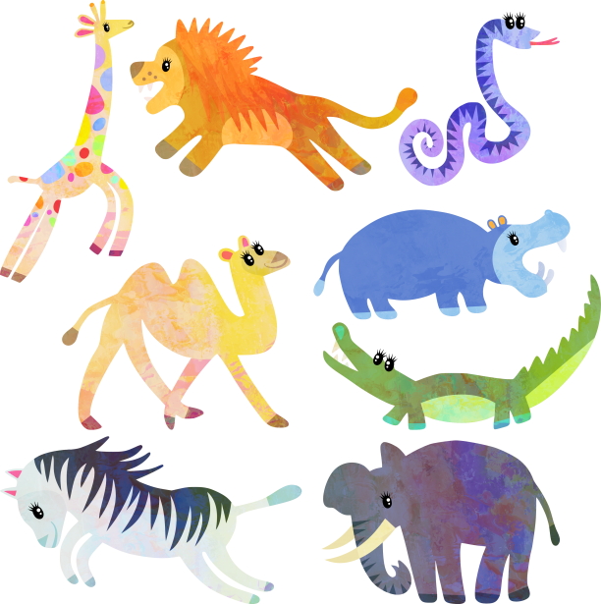    Animals, including Humans and Seasonal Changes
Knowledge and understanding of the world | Computing | Online safety | Animated stories
Knowledge and understanding of the world | History | Events beyond living memory- The Gunpowder Plot
Knowledge and understanding of the world | Geography |  | Physical and Human Geography - Wonderful World
Knowledge and understanding of the world | DT |  | Food and nutrition - healthy kebabs/sandwiches
Personal, social and emotional development | RE | Christianity - Myself, Being human | Christianity - Special to me, Life journey
Personal, social and emotional development | PSHE |   Relationships | Health and wellbeing
Personal, social and emotional development | Role Play | Aquarium Cafe, animal jungle reading area, farmyard small world play | Christmas workshop and sleigh
Creative Development | Art |   Drawing
Creative Development | Music | Singing | Singing
Communication, Language and Literacy | English | FS My news and Drawing Club  Y1 and 2  Traditional tales featuring animals  Stories with familiar settings  Animal Poems | FS My news  Y1 and 2  Animal fiction  Stories, letters and poetry linked to Christmas  Capital letters, full stops
Mathematical Development | Maths |   FS Place value, Addition and subtraction  Y1 & Y2 Place value, Addition and subtraction | FS Place value, patterns and shape, time  Y1 & Y2 Geometry- 2D and 3D shapes

