RSHE Parent Information Session
Relationship, Sex and Health Education
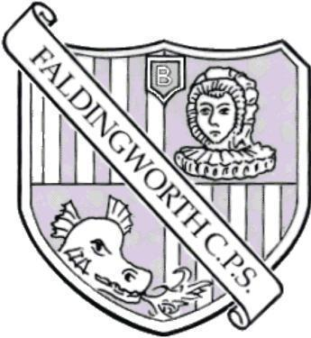
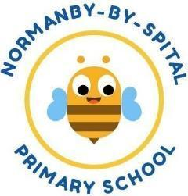
March 2025

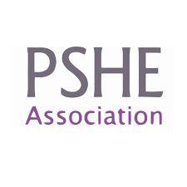
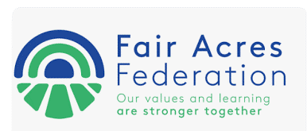
Aims:

Our aim is to give parents an overview of
- What is RSHE?
- Why do we teach RSHE?
- What does RSHE look like at the schools in the Fair Acres Federation?
- Your rights as parents
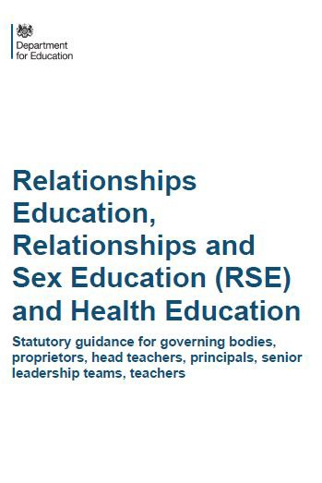
What is RSHE?

- Relationships, sex and health education
- a statutory part of the curriculum since 2020
- Primary schools MUST teach Relationships and Health Education
- Secondary schools MUST teach Relationships, Health and Sex Education
- Sex Education in Primary schools is recommended but not compulsory
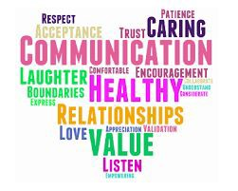
Relationships Education

‘The focus in primary school should be on teaching the fundamental building blocks and characteristics of positive relationships, with particular reference to friendships, family relationships, and relationships with other children and with adults.’ - DfE statutory guidance
- Families and people who care for me
- Caring friendships
- Respectful Relationships
- Online Relationships
- Being Safe
What children at Primary School should know about relationships

  - What a positive, healthy, caring, safe relationship looks and feels like
  - How to speak up and get help when a relationship does NOT feel healthy/positive/safe
  - How to make and maintain positive relationships
  - Relationships can be online and oﬄine
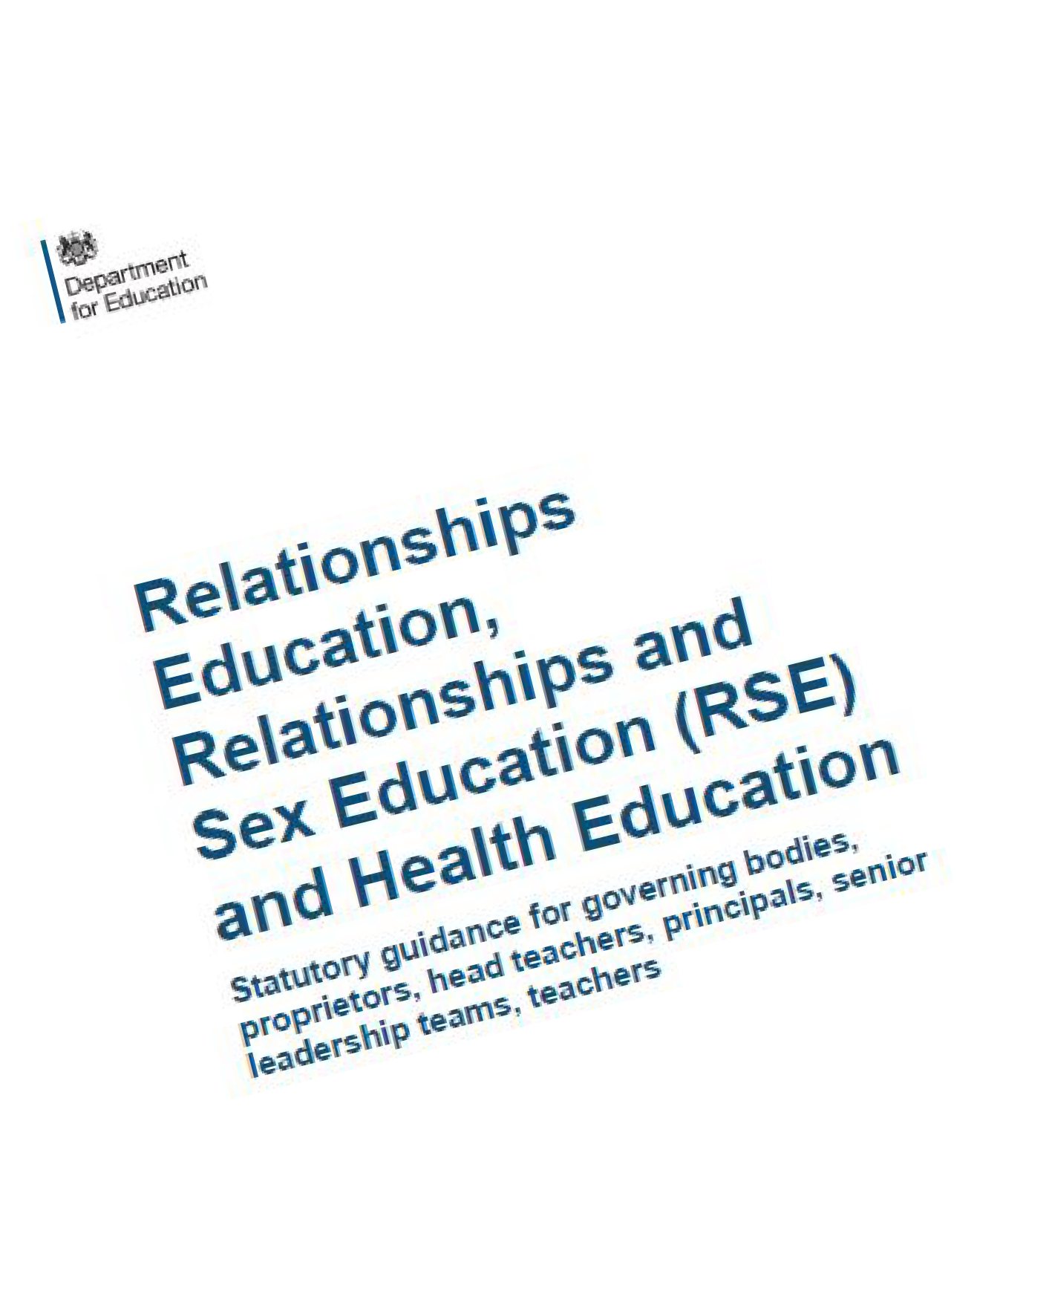
Schools must comply with The Equalities Act 2010
‘Schools must not unlawfully discriminate against pupils because of their age, sex, race, disability, religion or belief, gender reassignment…or sexual orientation (protected characteristics)
‘Schools should be alive to issues such as everyday sexism, misogyny, homophobia and gender stereotypes and take positive action to build a culture where these are not tolerated’
PSHE is a key part of this. All children are valued and included.
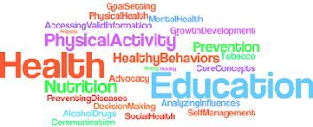
What are the expectations for Primary Health Education?

    - Mental wellbeing
    - Internet safety and harms
    - Physical health and fitness
    - Healthy eating
    - Drugs, alcohol and tobacco
    - Health and prevention
    - Basic First Aid
    - Changing adolescent body
What should children know about puberty?

    - Correct names for parts of the body, including genitalia - from year 1
    - How their bodies will change during puberty – from year 4
    - How to manage these changes/ practicalities
    - Why these changes need to happen
    - How and where to ask for help if needed
What about sex education?

- The statutory requirements do not extend to sex education at KS 1 and 2 (beyond the biological/reproductive aspects schools are already required to cover in science)

- However, the Department for Education ‘continues to recommend that all primary schools should have a sex education programme tailored to the age and the physical and emotional maturity of the pupils’

- Where schools provide sex education at key stages 1 and 2, parents have the right to withdraw their child from sex education but not from statutory Relationships Education or Health Education
Science & Sex Education in Primary School

Key Stage 1

identify, name, draw and label the basic parts of the human body and say which part of the body is associated with each sense

notice that animals, including humans, have offspring which grow into adults
Key Stage 2
describe the differences in the life cycles of a mammal, an amphibian, an insect and a bird
describe the life process of reproduction in some plants and animals
describe the changes as humans develop to old age
learn about the changes experienced in puberty
We define Sex Education as…

Human reproduction - sexual intercourse, conception, pregnancy and birth
Sex Education is NOT about sexual activity!
Sex Education and is delivered in Years 5&6

Why is this all so important?

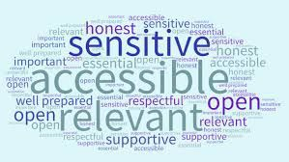
Today’s children and young people are growing up in an increasingly complex world and living their lives seamlessly on and oﬄine.

In this environment, children and young people need to know how to be safe and healthy, and how to manage their academic, personal and social lives in a positive way.

There is compelling evidence that PSHE education —which includes relationships, sex & health education— helps keep children and young people safe, mentally and physically healthy and prepared for life and work.

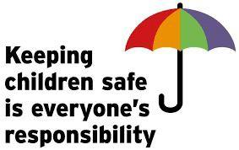
PSHE/RSHE and Safeguarding

PSHE/RSHE education is a critical component of safeguarding in schools.
The Department for Education (DfE) recognised PSHE education’s importance to safeguarding when it introduced statutory RSHE in 2020.
The statutory guidance, Keeping Children Safe In Education, states that ‘Schools and colleges play a crucial role in preventative education’ and stresses the importance to this of ‘a planned programme of
evidence-based RSHE delivered in regularly timetabled lessons’

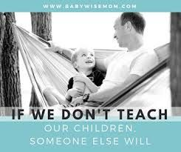
Why is this all so important?

When it comes to relationships and sex, children’s heads are probably not empty – but they may be full of myths and
half-truths.


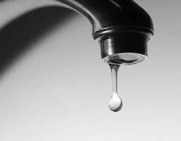
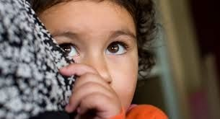
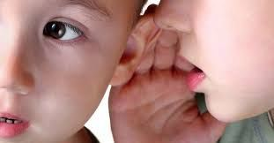

What is the best approach to RSE?

Don’t forget…

We are educating children and young people to live in the real world, with all its contradictions.
We mustn’t let our adult knowledge of relationships and sex prevent us seeing things from a child’s perspective
Our focus should be on building healthy attitudes and positive relationships, not just fighting off perceived threats
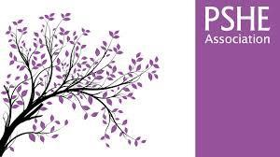
What does RSHE look like at our schools?

We use the PSHE Association thematic programme model for our PSHE curriculum content and objectives. It takes a thematic approach to primary PSHE education, covering all three core themes of the Programme of Study taught over the school year with three topics per half term. The curriculum is supported with a range of suitable resources from the PSHE Association and other places: Medway lesson plans (Relationships and sex education) and St John’s Ambulance (First Aid teaching materials). This approach allows different year groups to work on similar themes at the same time, building a spiral programme year on year, whilst offering flexibility in terms of medium-term planning. It also gives the opportunity to differentiate learning depending on the specific cohort (for example for SEND pupils and different maturity levels of children. All gender groups are taught together.
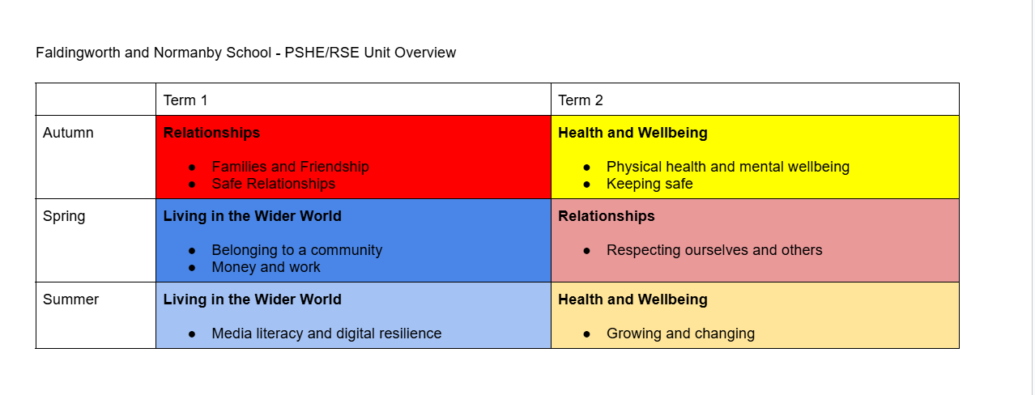
Overview of studies

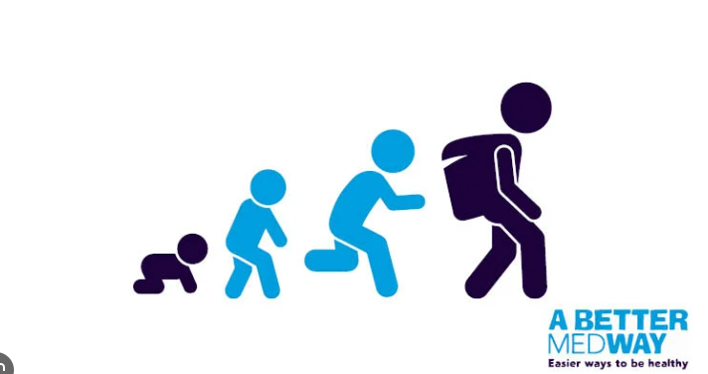
See our school website to view the resources used in our RSHE lessons for years 1-6- K S1
Families - KS1
Failies - KS2
Families - KS2

Mental Health & Emotional Wellbeing - KS2
Mental Health & Emotional Wellbeing - KS2

Changing & Growing Up - KS1

Changing & Growing Up - KS2

